If we are using windows, then we probably know the Microsoft Management Console (MMC), which provides a common framework for system management. SAP has developed the SAP Systems Manager snap-in which allows you to monitor, start or stop SAP systems centrally from the MMC, this simplifying system administration. Under Unix, however, for a long time no such tool was available.
But with SAP NetWeaver 7.0, things finally got moving:
- A new start service (sapstartsrv) is available on all platforms. It is offering web service interfaces to applications for centrally administering and monitoring SAP systems.
- With a similar UI to the SAP Systems Manager snap-in of the MMC, the SAP Management Console(SAP MC) was developed, which uses the web services mentioned above. The SAP MC is a browser-based, platform-independent user interface providing basic monitoring and administration of SAP systems.
- Within the development of SAP NetWeaver 7.1 the web service interfacs were further improved. These functions are already available to you in the SAP NetWeaver Composition Environment 7.1. To some degree, a downport of these functions to NW 7.0 is planned.
This weblog introduces the SAP MC. Technically, it’s a Java applet running in a Java Runtime Environment on the front end host.

Summarized, the SAP MC allows you to monitor and perform basic administration tasks on SAP systems centrally, thus simplifying system administration. Among other things, it provides the following functions:
- Monitor and control (start, stop, or restart) SAP systems (ABAP and Java) and its instances with a single tool.
- Display SAP log and trace files, start profiles, instance parameters, the system environment, SAP environment, and so on.
- Display and control Java and ABAP processes.
- Monitor system alerts.
If you want to use the SAP MC, you need a Java Runtime Environment with a release as of release 1.4 on your front end. Besides, the corresponding Java Plug-In has to be active on your browser. To start the SAP MC, simply enter the following URL into your web browser:
http://<host>:5<instNum>13

Now, simply choose Start.

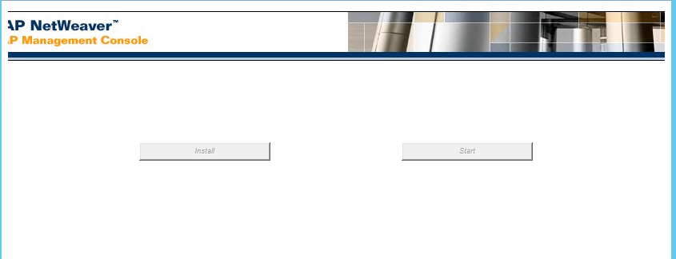

Depending on the patch level of the SAP system, the values of the system entered in the URL are shown. If not, you can always add instances manually, using the pushbutoon “Add new instance”.
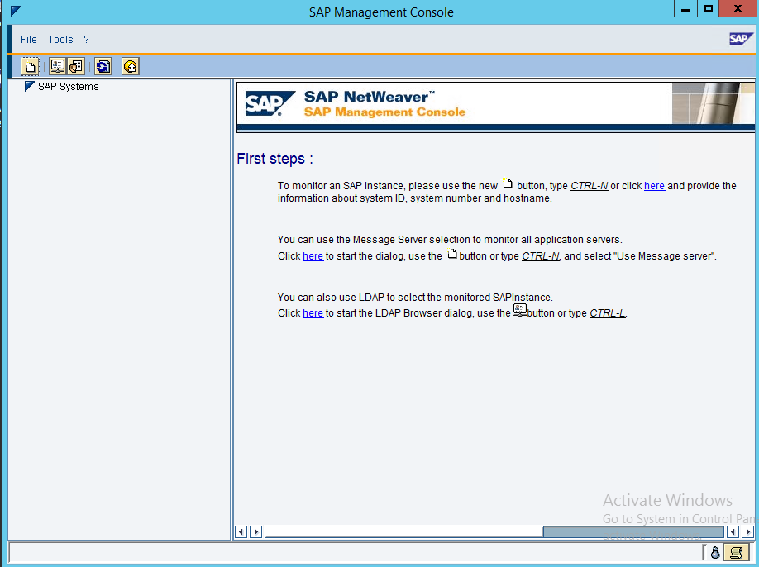
Now specify the host parameters of the SAP system you want to display:
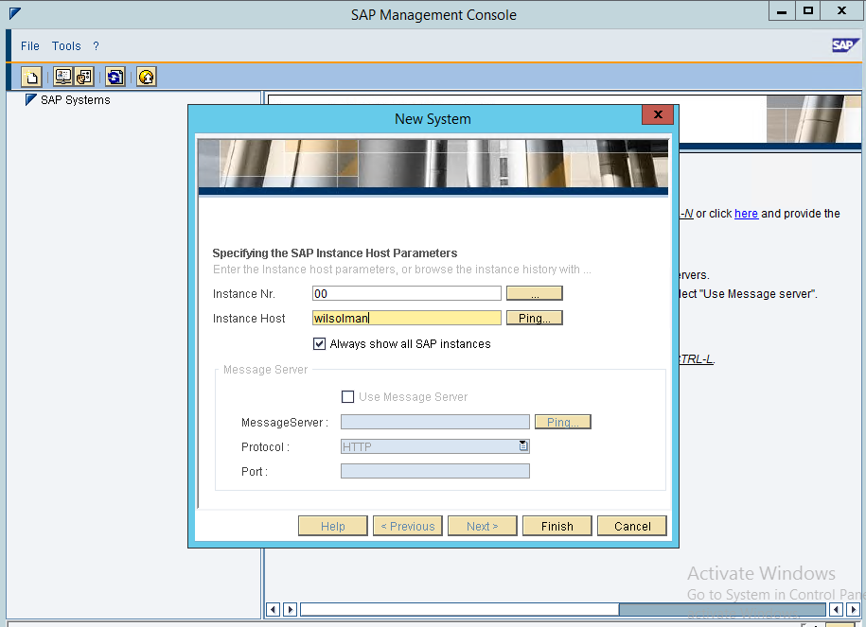

Now login with User ID with Paswword.
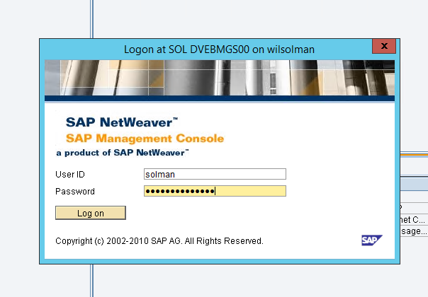

As you can see, the UI is similar to the MMC:

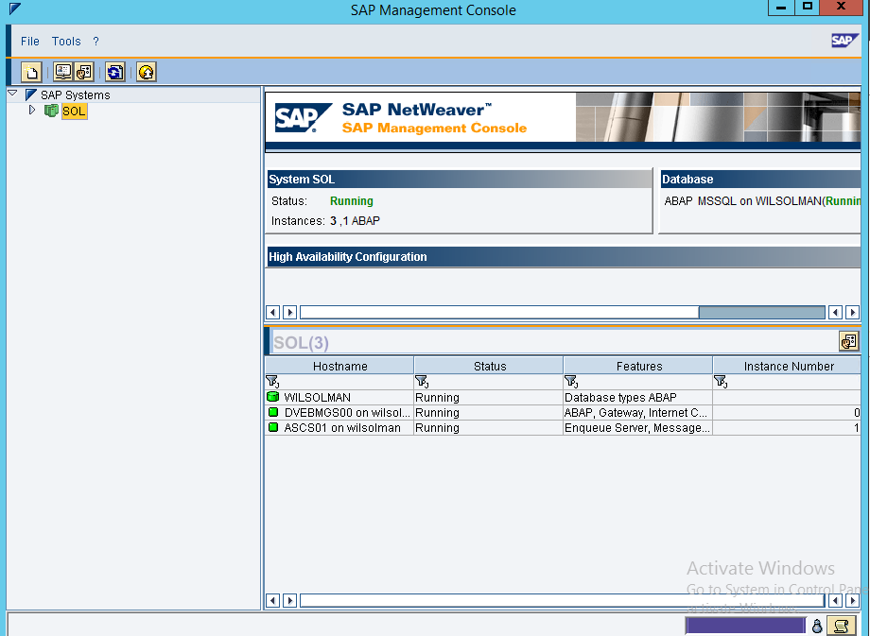

Remember that this the documentation of the SAP NetWeaver Composition Environment, so for your NW 7.0 system not all of the functions mentioned there are available.
Some remarks about the UI:
Right click an instance or a system to get more commands on that level:

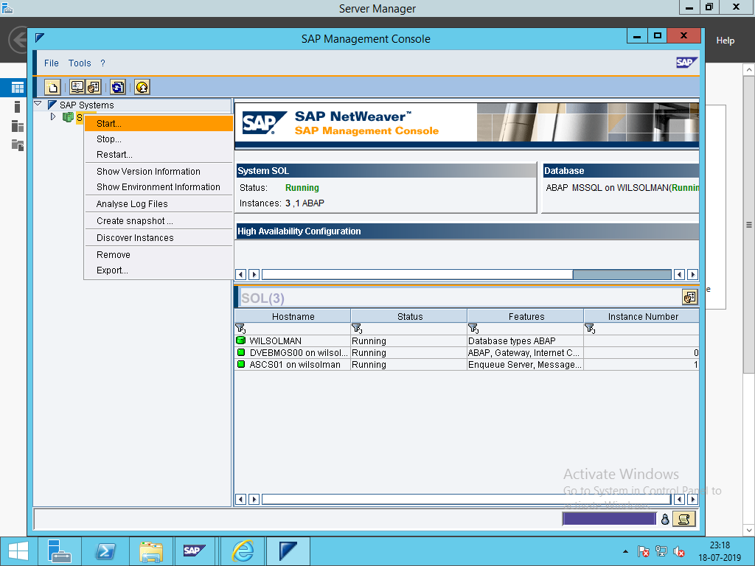

Entries below instance levels often contains sub trees; the corresponding icons appear after you’ve chosen the corresponding entry. As an example, you can see the sub trees for system monitoring, which show the current status and open alerts reported to the CCMS monitoring segments of the corresponding instance.

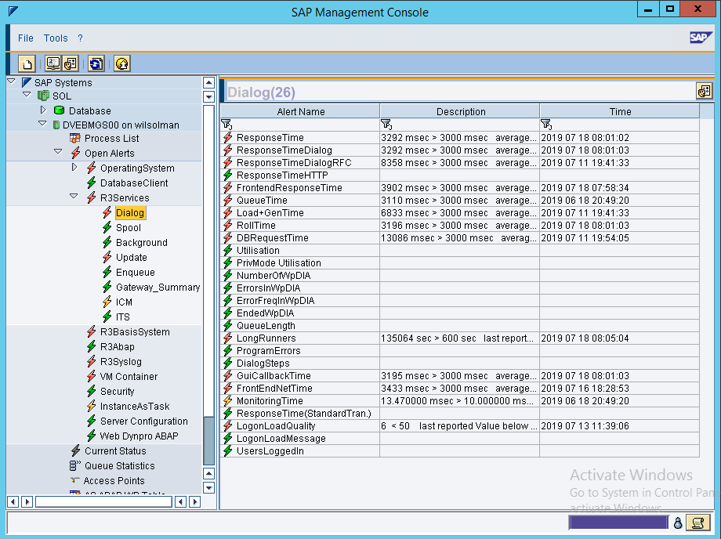

One remark about monitoring of Java instances. In release SAP NetWeaver 7.0, there is the entry AS Java containing a process table with information about the Java processes:
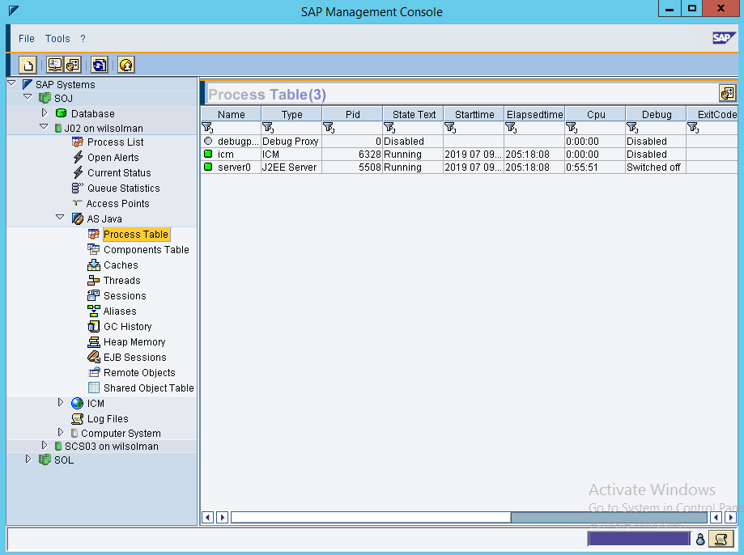

In SAP NetWeaver 7.1 however, you can see much more. If you add a Composition Environment (CE) instance, you can see a whole bunch of extremely important monitoring values – representing one of the most complete and comprehensible collection of metrics about Java monitoring. In detail, it contains:
- information about the AS Java threads, sessions, caches, aliases, Enterprise JavaBeans (EJB) sessions, remote objects
- Java Virtual Machine garbage collection and heap memory information of the application server

