APPLIES TO:
SUSE LINUX 11 SP3 INSTALLATION
SUMMARY
This article explains SuSE Linux 11 SP3 Installation in VMware
AUTHOR: K.VENKATA RAMU. COMPANY:
Willsys Infosystems Pvt. Ltd.,
CREATED ON:
11th SEPTEMBER 2017.

STEP 1:Open VMware

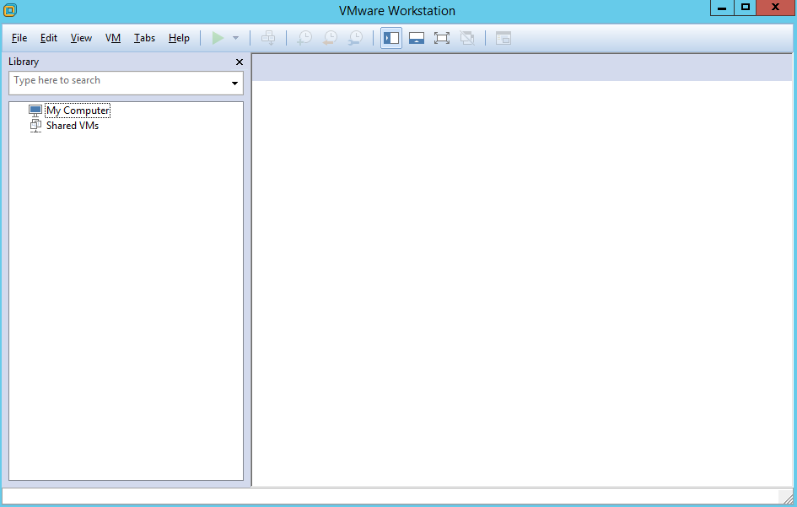

STEP 2: Click -->File -->New Virtual Machine

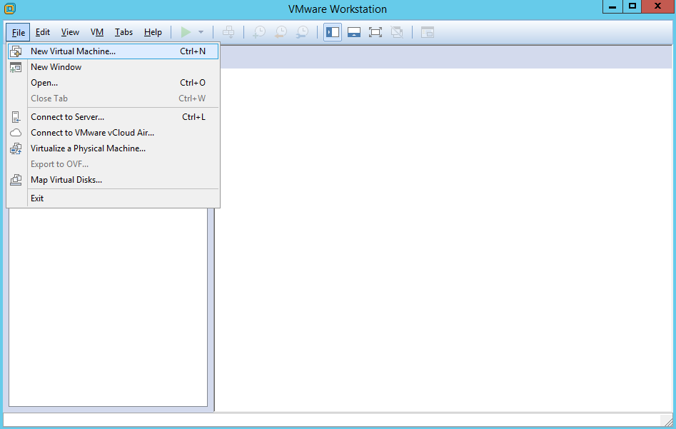

STEP 3: Select Type Of Installation -->Typical

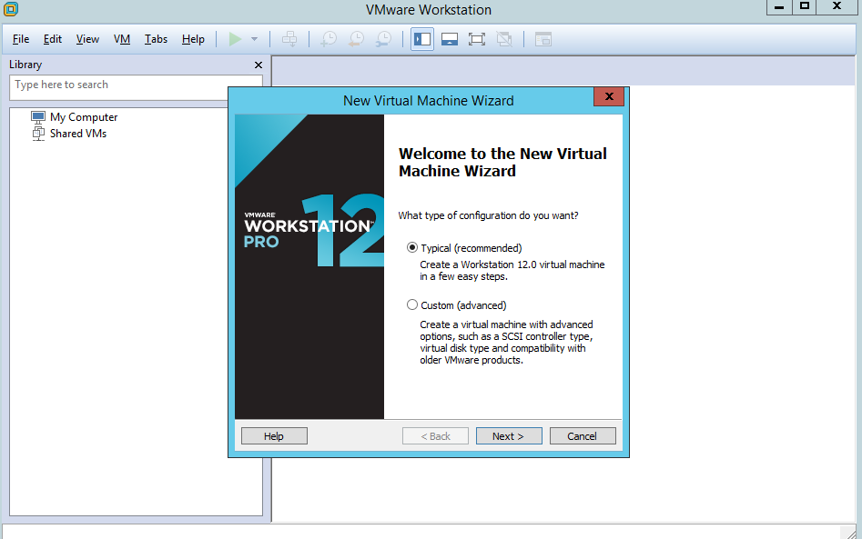

STEP 4:Select ISO file In Physical System -->Browse -->Select ISO file -->click Next

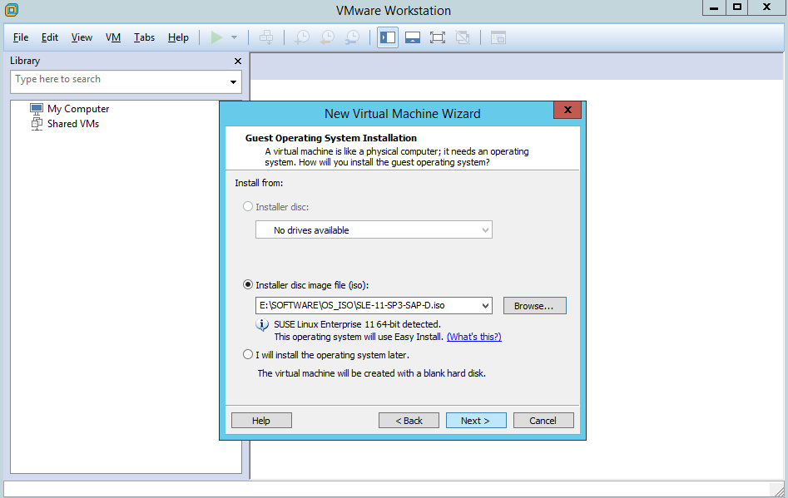
STEP 5:Create UserName And Password .This Password For Both USer And Root Account
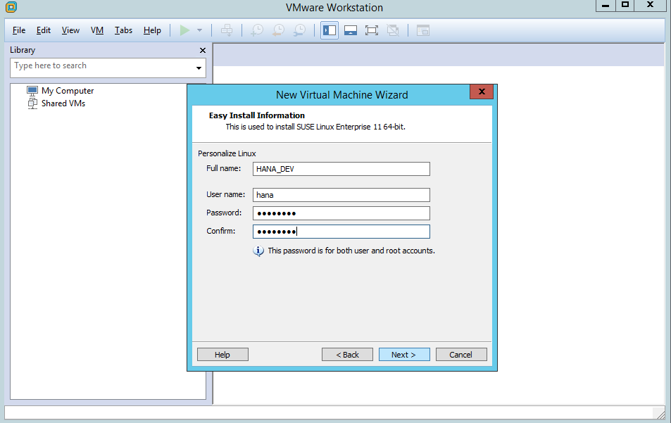

STEP 6:Click -->Next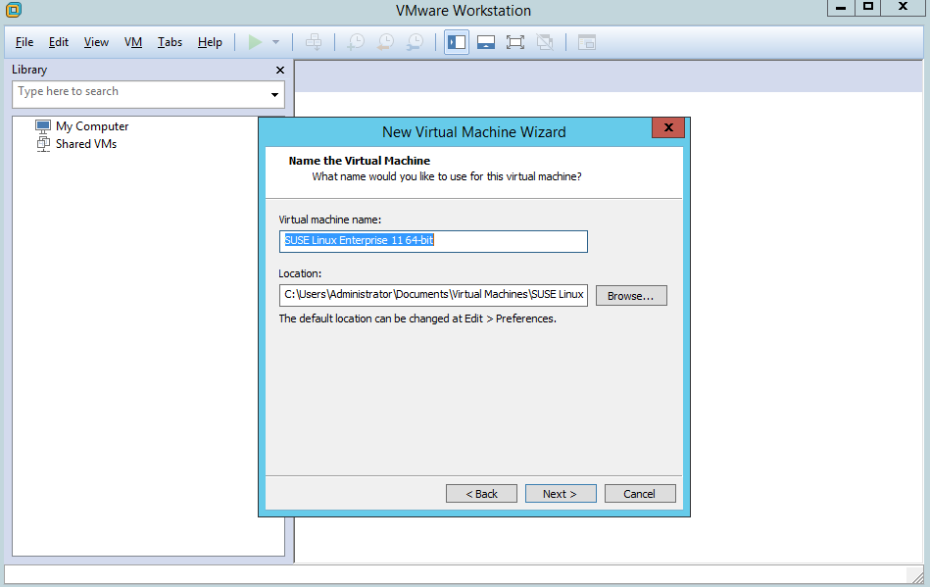
STEP 7: specific virtual machine Disk Size based on requirements.
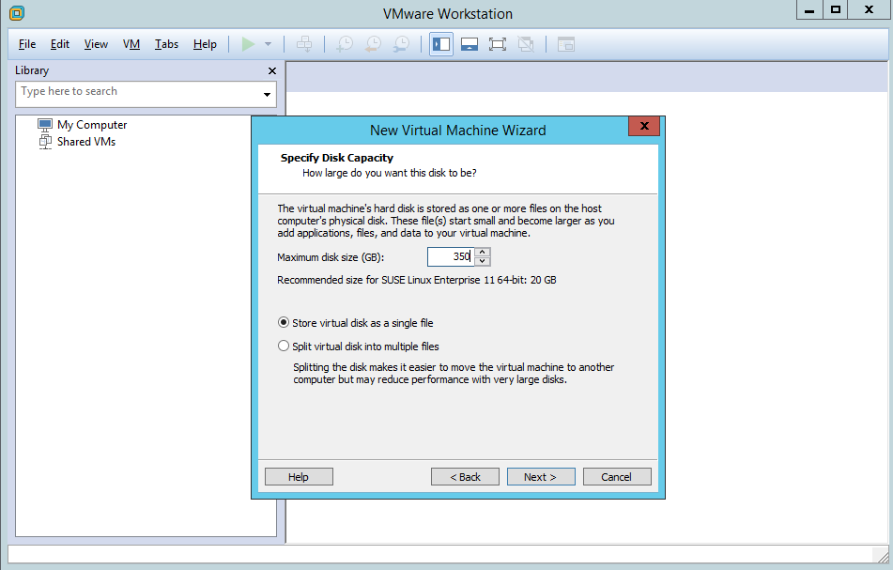

STEP 8:Click -->Customze Hardware ---> specific virtual machine RAMSize based on requirements.
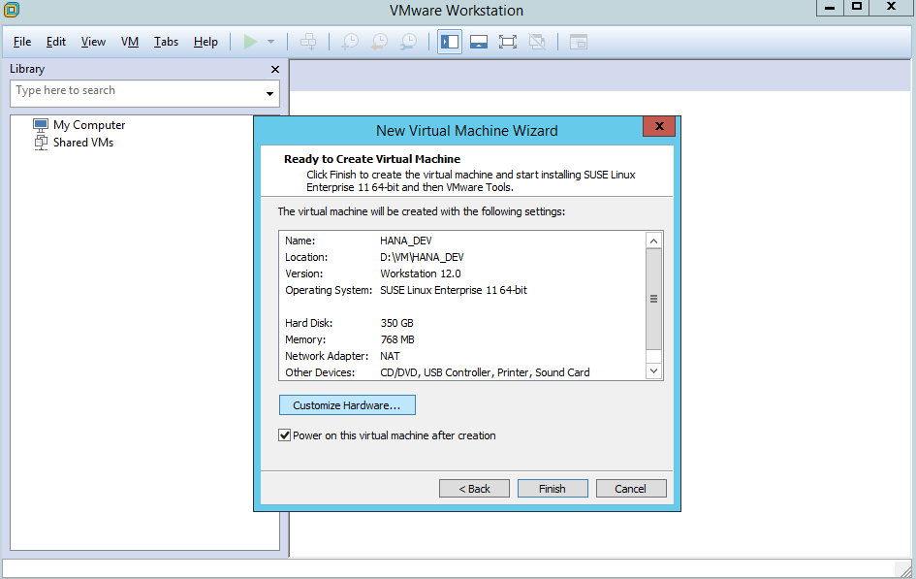
STEP 9:Cilck -->Finish
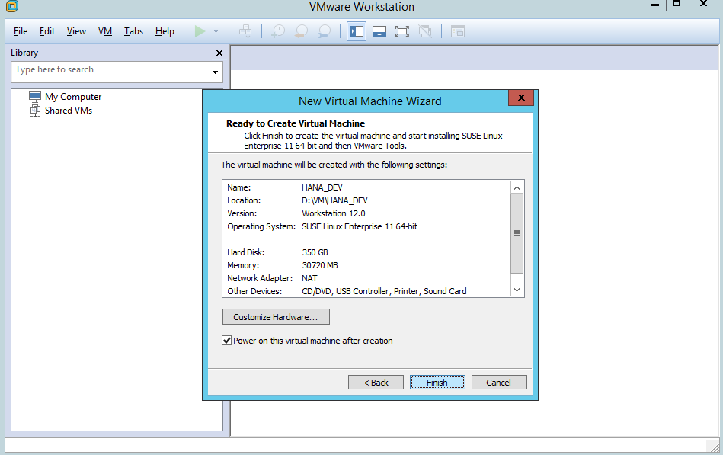

STEP 10:SuSe linux Installation Start automatically.

