HANA MIGRATION USING SUM DMO:

Source:
SAP-SAP Netwever 7.5 -0000
OS - Windows Server 2012
Database - MSSQL 2012
Hostname: sapnetweaver
SID: EHI

Target:
SAP-SAP Netwever 7.5 -0003
OS - SUSE Linux
Database - HANA 1.0 SPS10
Hostname: dmo-mig
SID: IHE

Tool:
SUM with DMO 1.0SP17
SAP Update or Upgrade through SUM SUM : It is a comprehensive Tool that is used Apply the Support packages/Add-ons, Kernel Update and SAP Upgrade. Download the latest SUM from SAP Market Place along with the SUM Note. The Software Update Manager (SUM) is the tool for various system maintenance procedures such as:
• Release upgrades (major release change) 7.0, 7.1, 7.3, 7.4 to 7.5.
• System updates (EHP installation) ERP6 to ERP 6 EHP4,5,6,7,8.
• Support Packages (SPs) / Support Package Stacks applications (SP0 to SP3).
• Java patches applications.
• Corrections of installed software information (Kernel and Single Support Packs).
Conversion of SAP systems to SAP S/4HANA.
In addition it offers the following options and features:
• DMO: Database Migration Option (system update combined with database migration to SAP HANA, SAP ASE, or MS SQL)
• ZDO: Zero Downtime Option (upgrades without a technical downtime and with a minimized business downtime)
• nZDM: Near-Zero Downtime Maintenance(includes features to minimize Business Downtime)
• Benchmarking Tool
• Table Comparison
• Customer Release

Notable points:
Source system preparation:
- Add the system to the solution manager system.
- Download the stack.xml file using MOPZ from SAP Solution Manager.
- Download the software media for update/upgrade using SDM.
- Download latest SUM tool for upgrade.
- Kernel must be upgraded to the latest version.
- Download the kernel for target system(for DMO).
- Install HANA DB client and set the environment variable.
- Check the space in trans directory.
- SAP host agent should be with latest version.(7.21 above)
- Copy the SUM<version>.SAR file to /usr/sap/SID of target system.
- Login to SIDADM user & UNCAR the SUM<version>.SAR file.
- After UNCAR u get the SUM folder.
- Navigate to /usr/sap/SID/SUM and run the following scripts to start SL controller.
./STARTUP
./STARTUP confighostagent
The SAP host agent is a tool for monitoring and controlling SAP instances and non SAP instances, operating systems, databases. As part of the SAP instance, the SAP Host Agent is automatically upgraded with the SAP kernel. Make sure that at least the relevant SAP Host Agent should be more than 7.21.
http://sapnetweaver:1128/lmsl/sumabap/SID/doc/sluigui.
provide sidadm user id and password.

Target system preparation:
- Install HANA database 1.0 SP10.
- Install HANA DB client.
- Install HANA studio.
- Download the Migration key for DMO.
- Download the HANA license.
- Make sure both systems are communicating.

Procedure:

1.Install HANA server first.

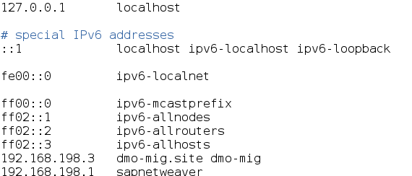

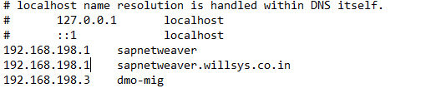

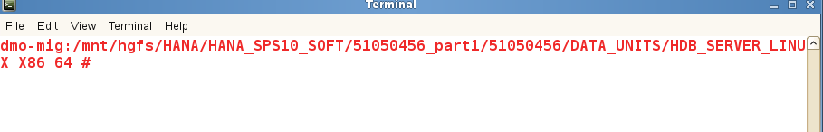

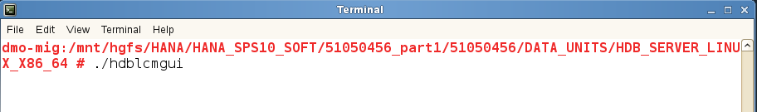

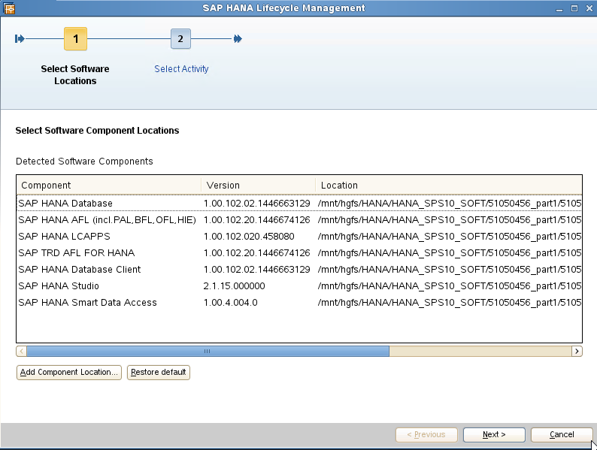
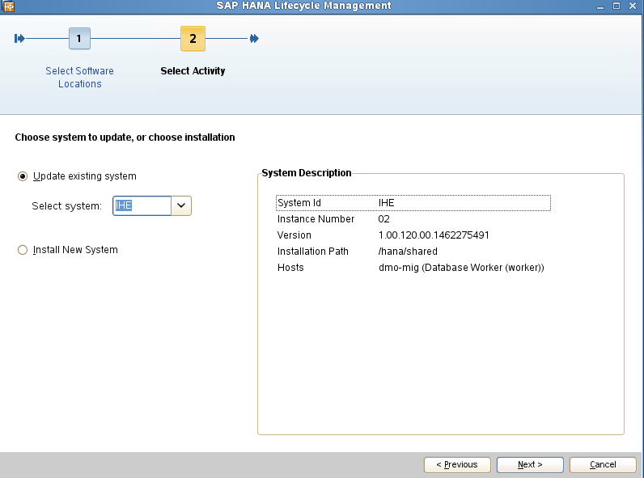

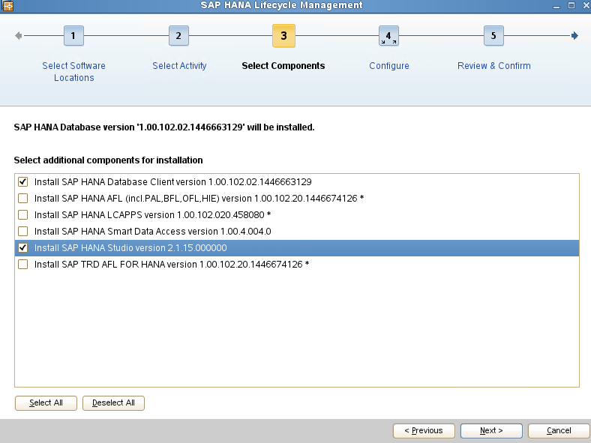
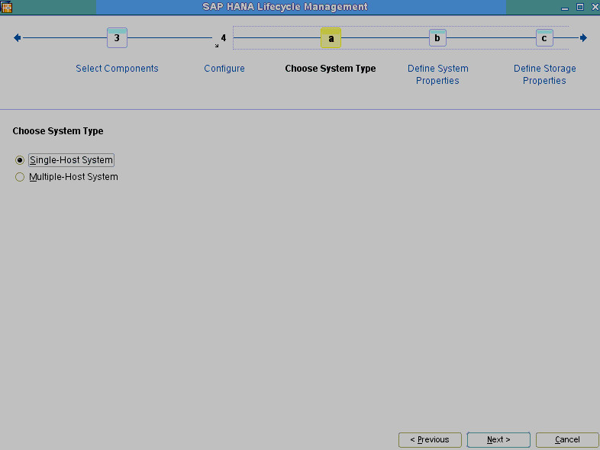
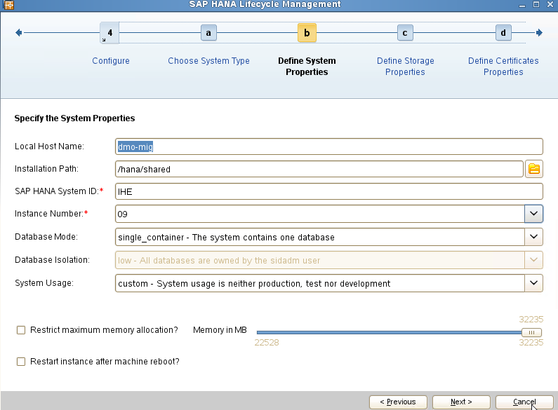
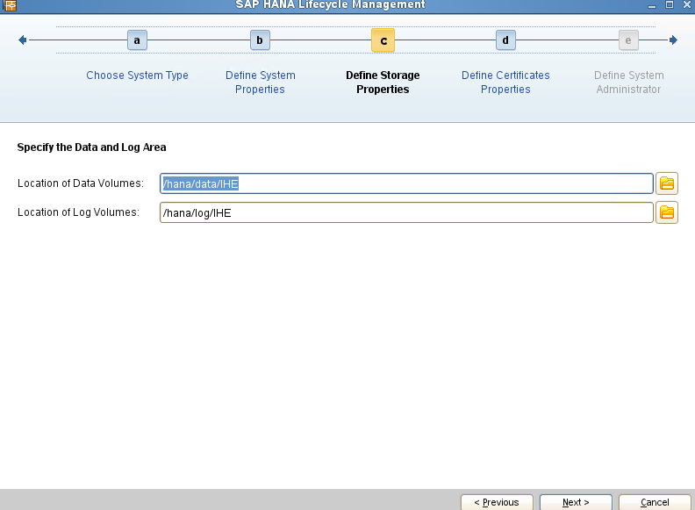
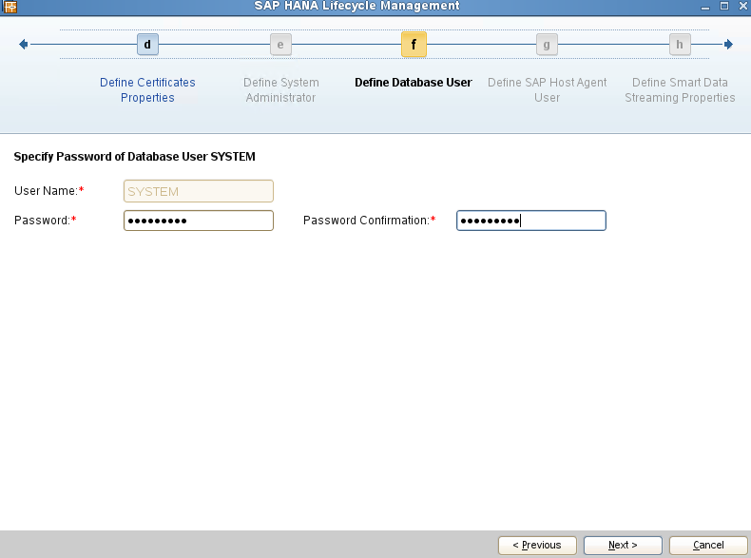
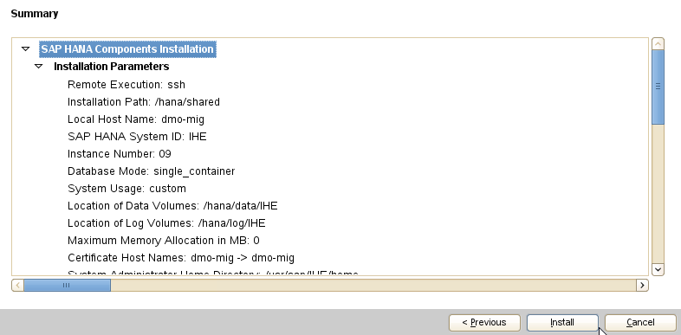
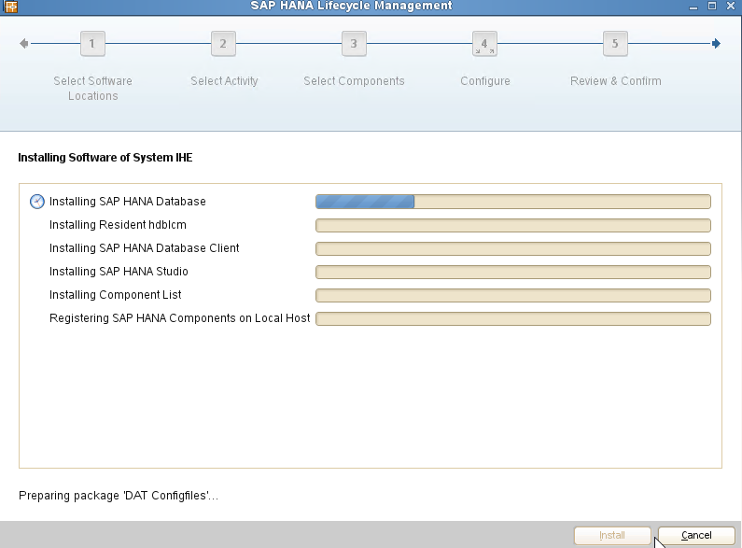

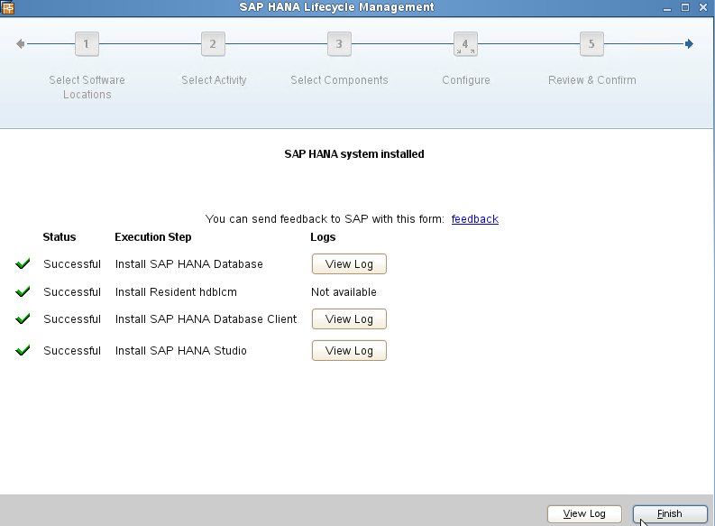

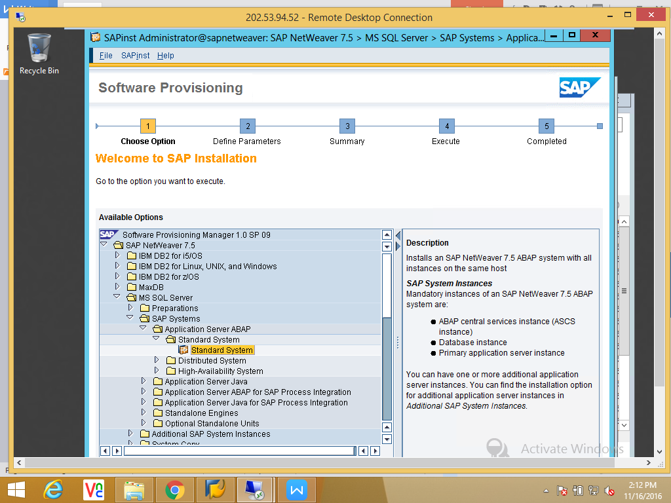
-->Download latest SUM and copy to /usr/sap/SID.
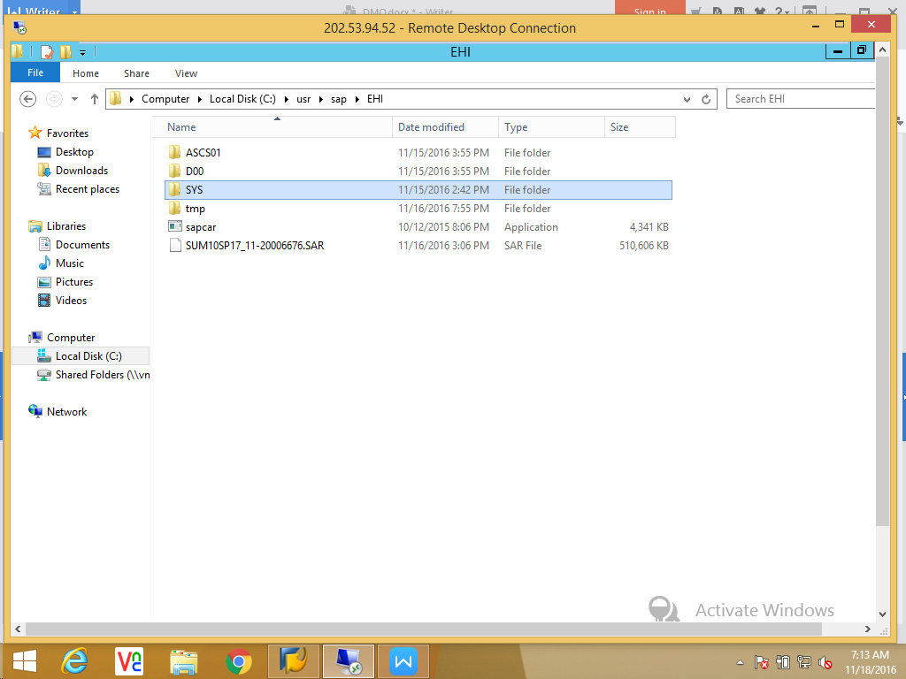

-->UNCAR the SUM<version>.SAR file.
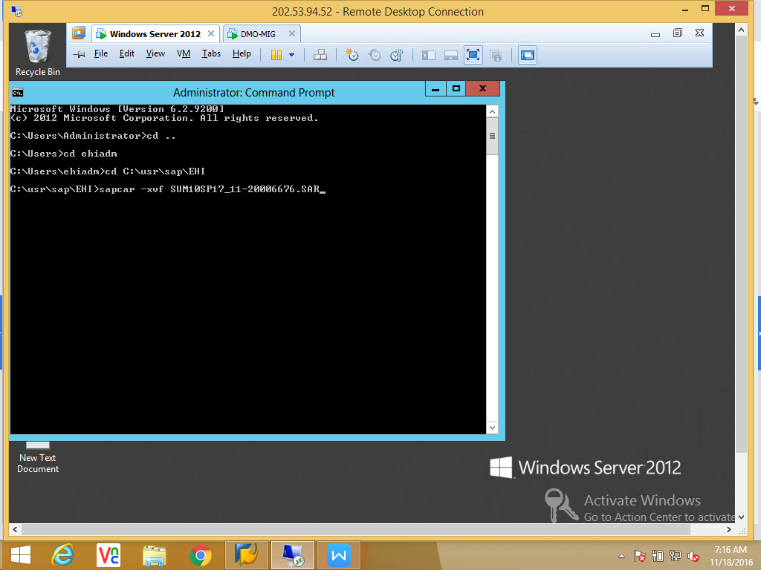
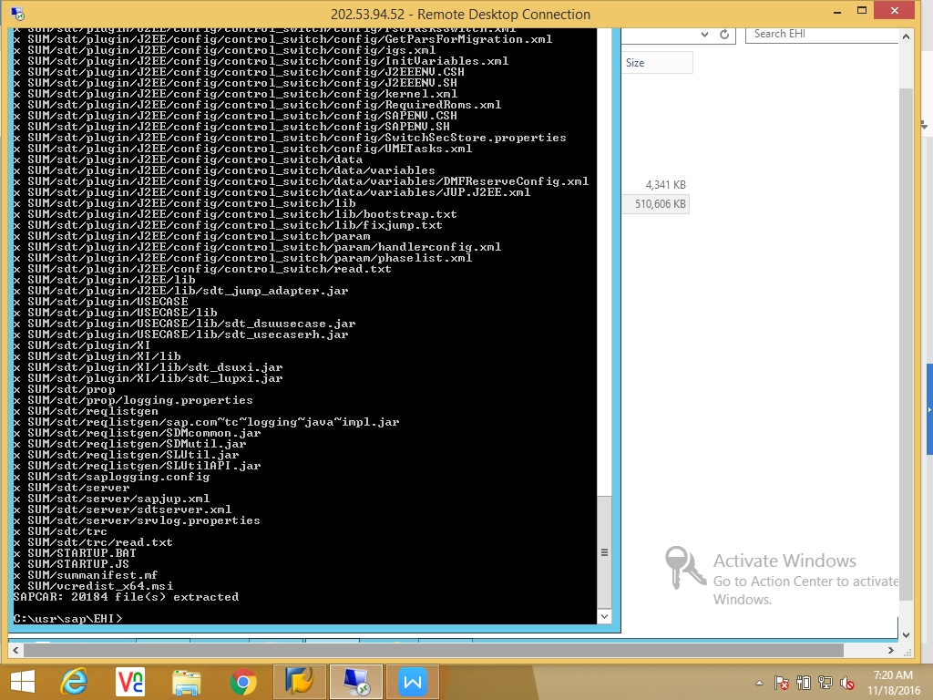

-->Login to sidadm
-->Navigate to /usr/sap/SID/SUM and execute slcontroller scripts.
-->STARTUP.BAT
-->STARTUP confighostagent

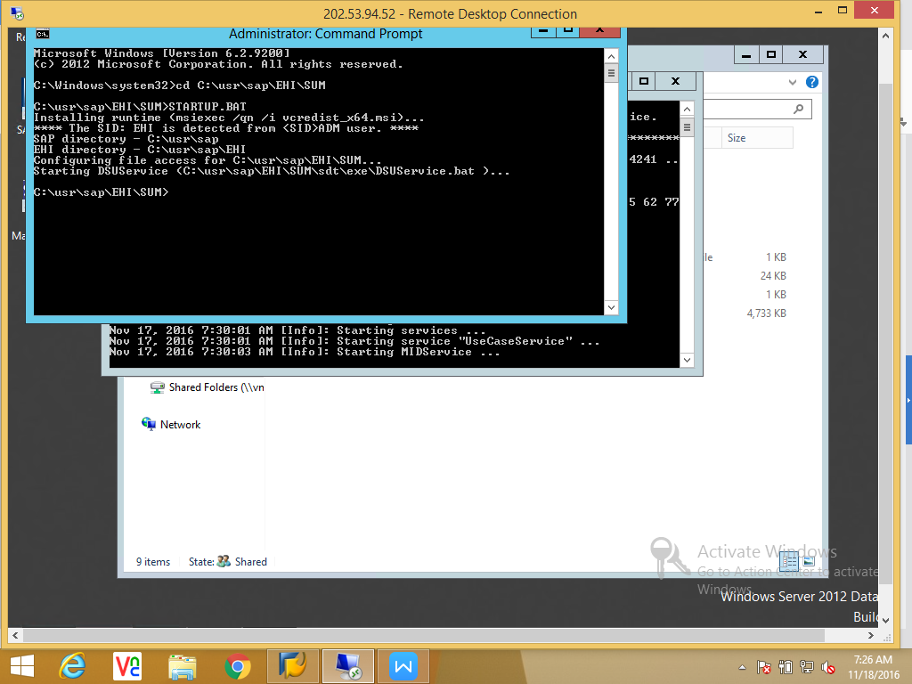

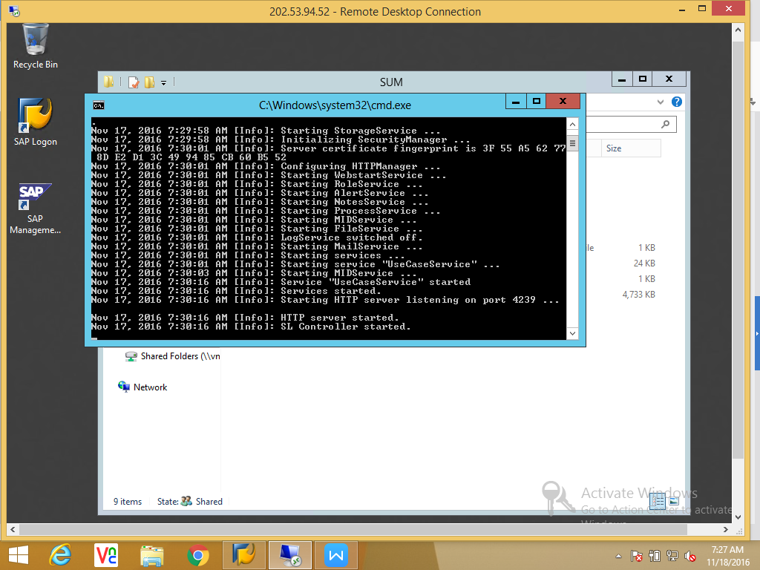

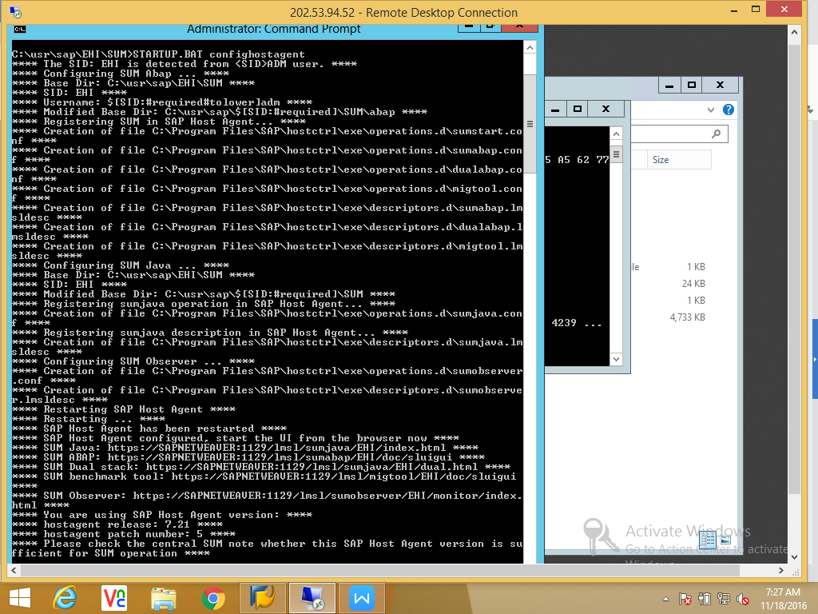

-->Now login to Administrator and launch SUM with predefined URL.

http://hostname:1128/lmsl/sumabap/SID/doc/sluigui and login with sidadm.

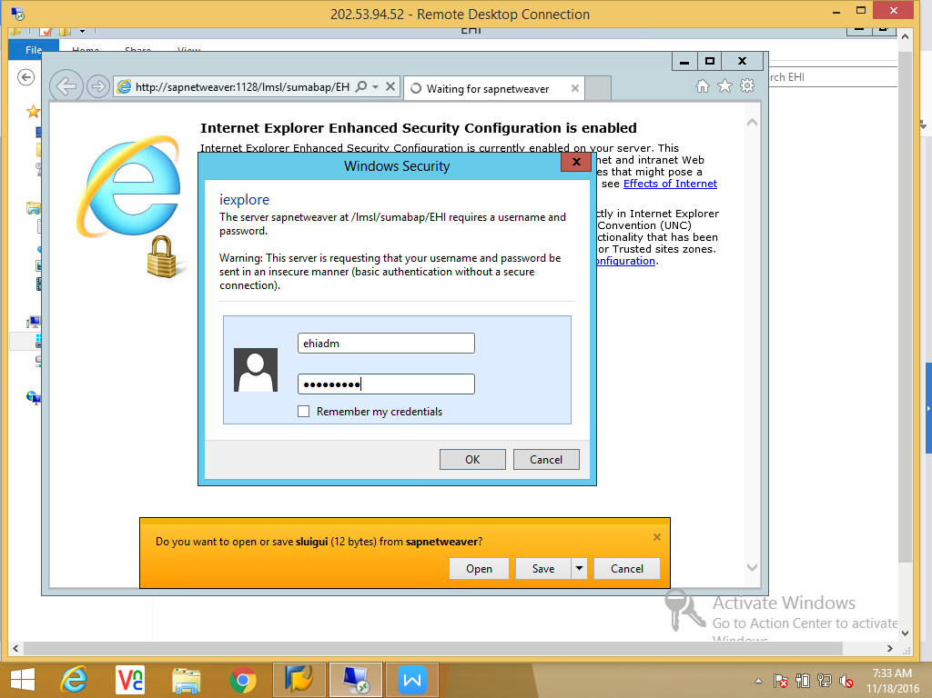

-->Provide the Stack .XML file path.

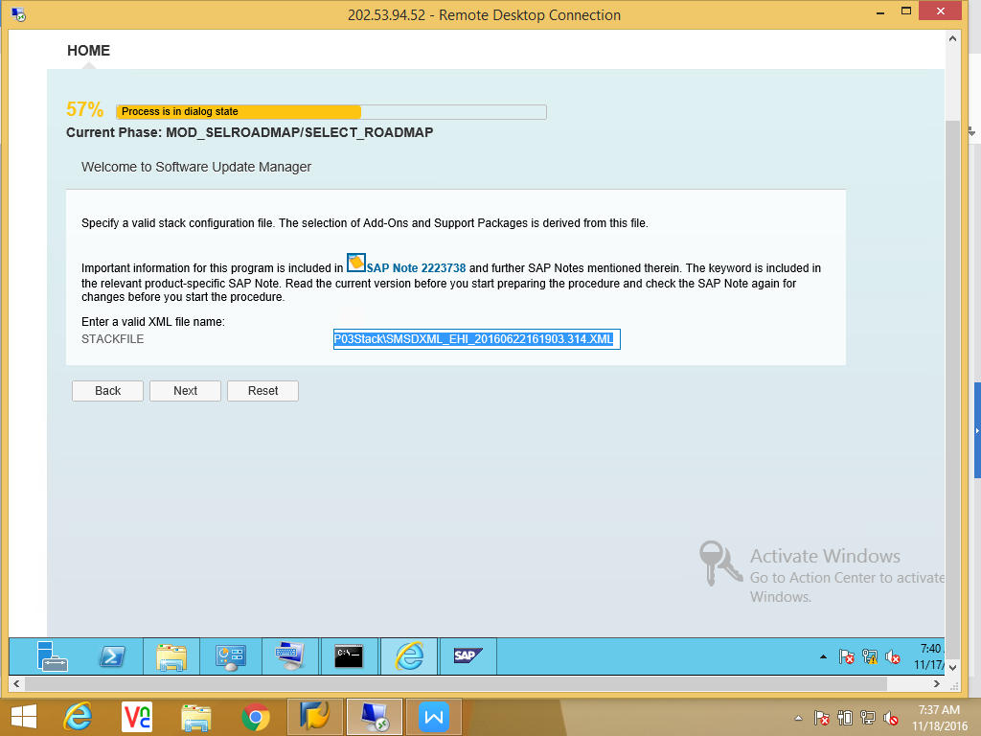
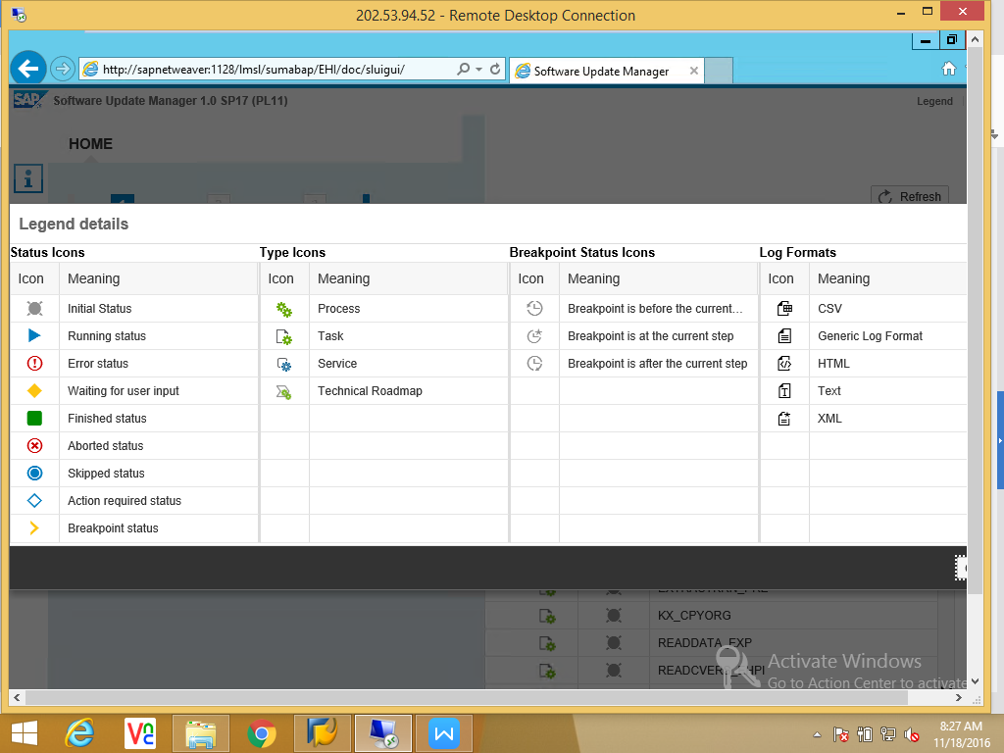

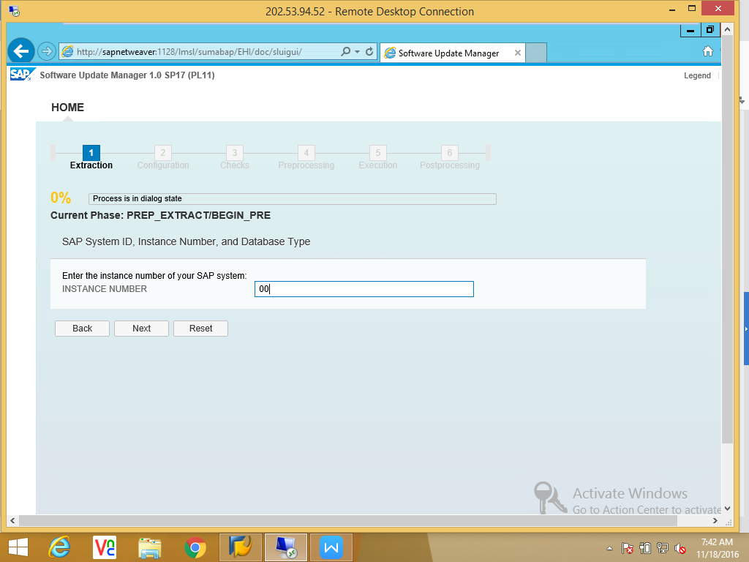

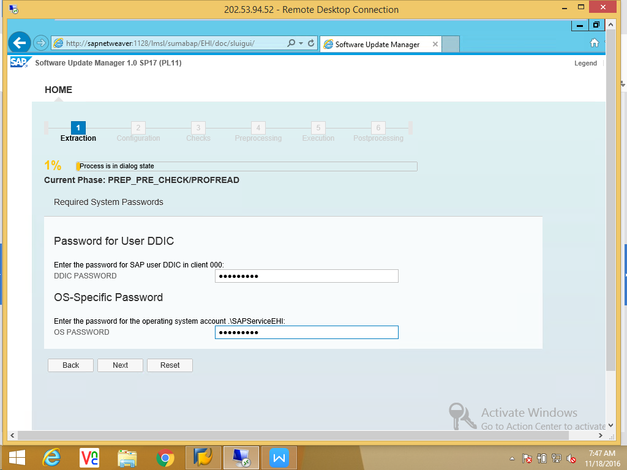

-->Import SPAM/SAINT 61.
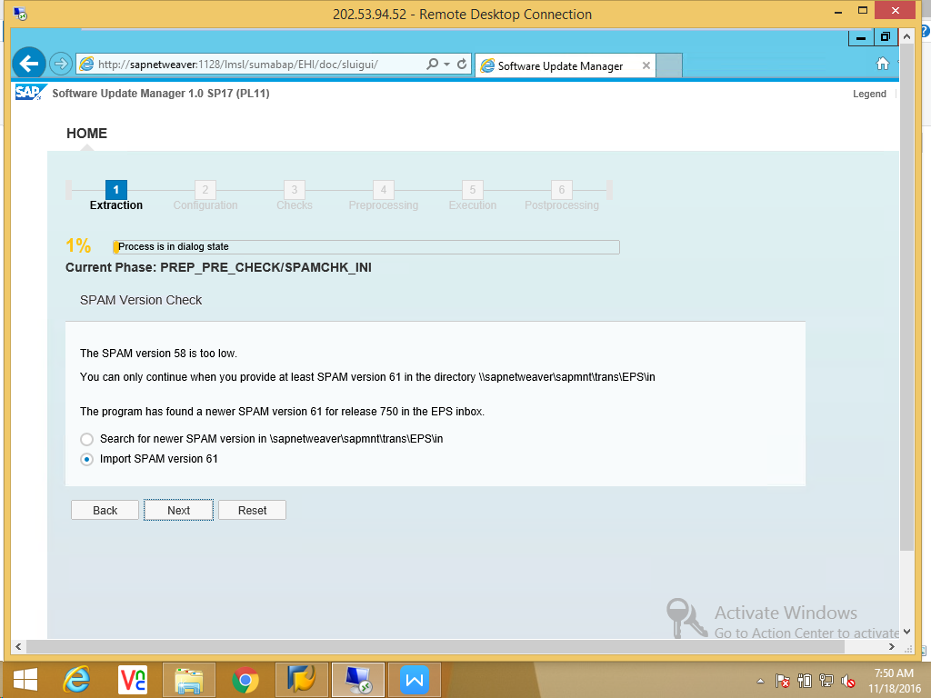

_->SLICENSE status INITIAL so got stuck.
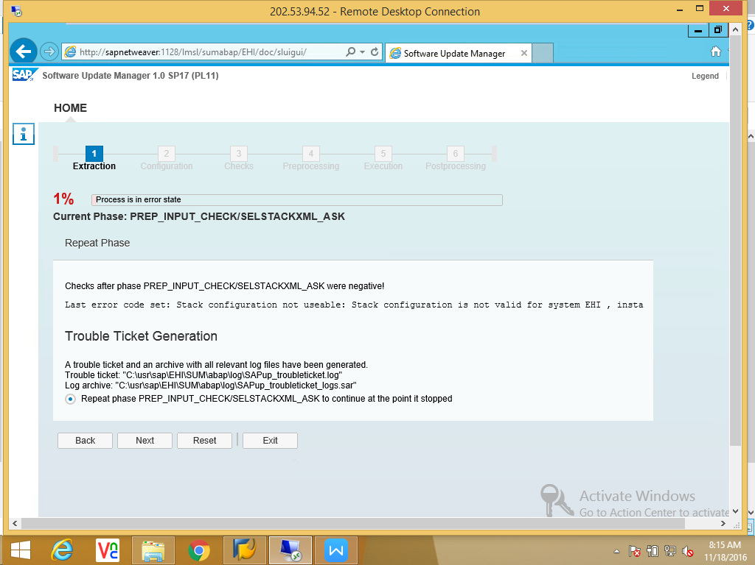

Apply license and retry.

-->Select Migration option for HANA.
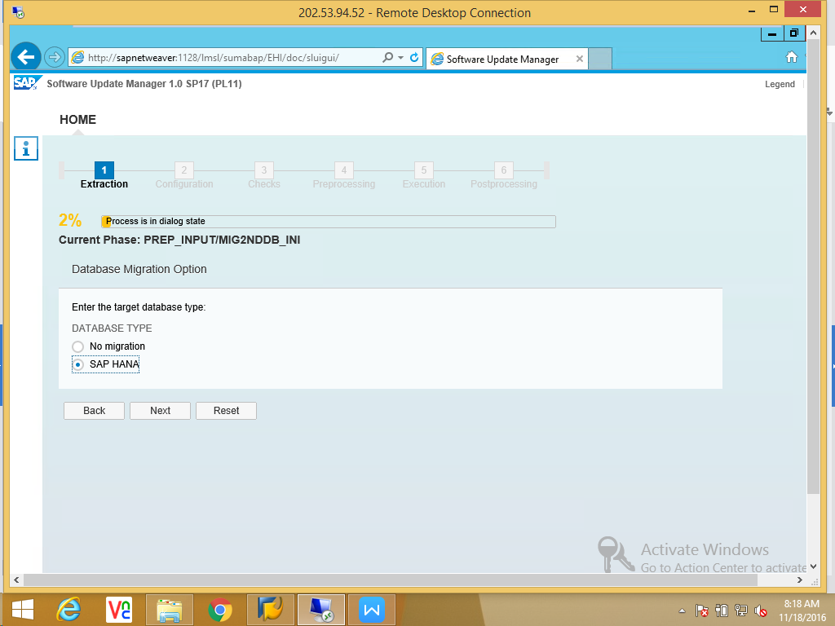

-->Provide the Migration key for DMO.
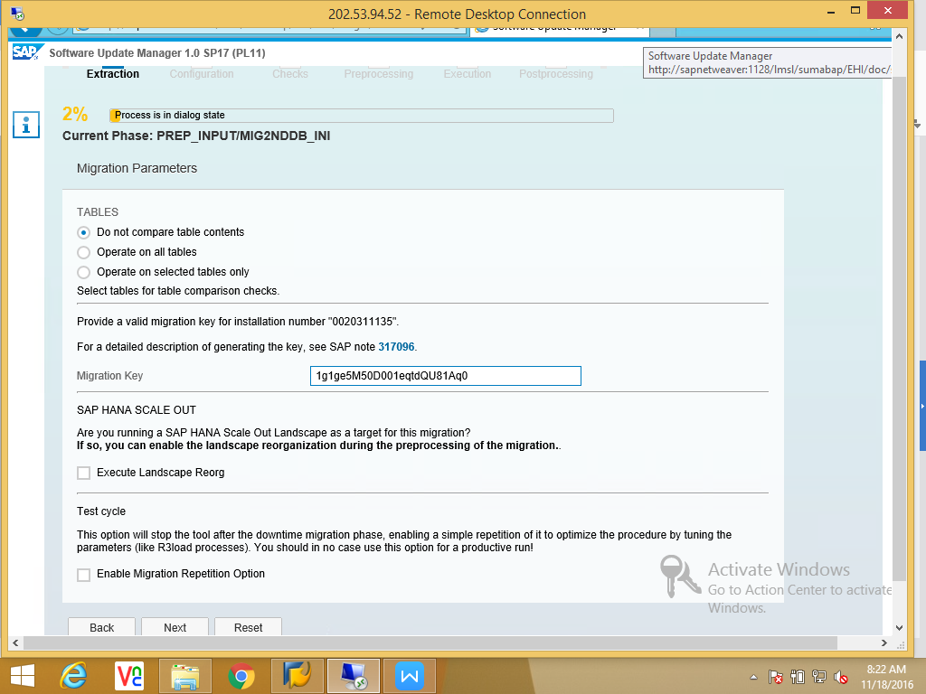

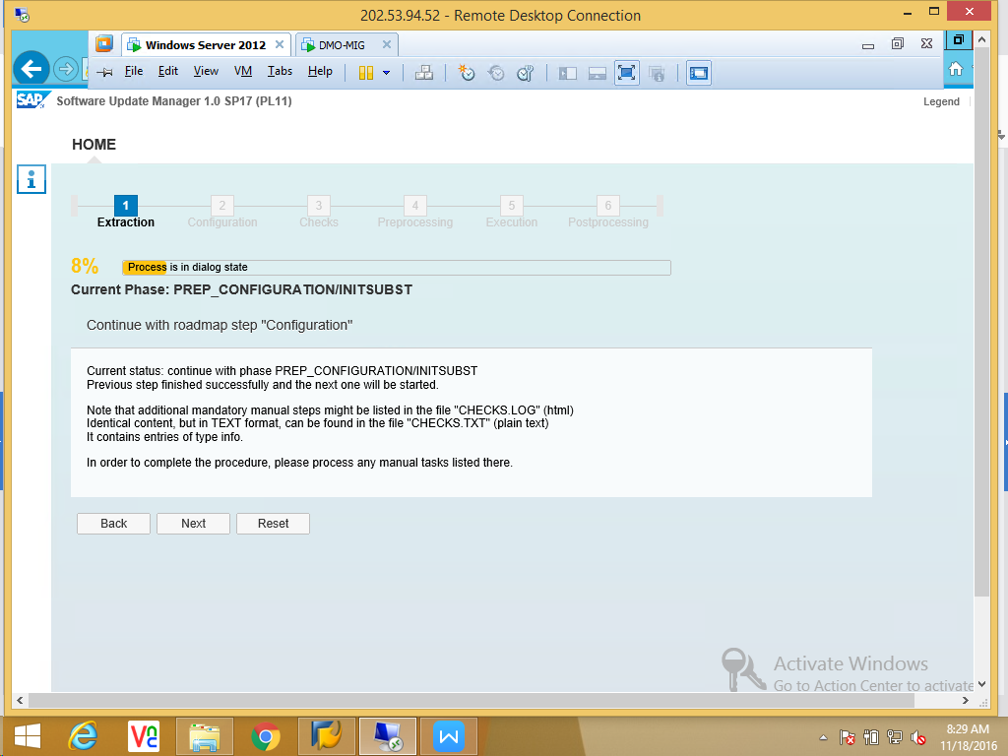

-->Extraction phase completed contine to next phase Configuration.

Select the SUM configuration.

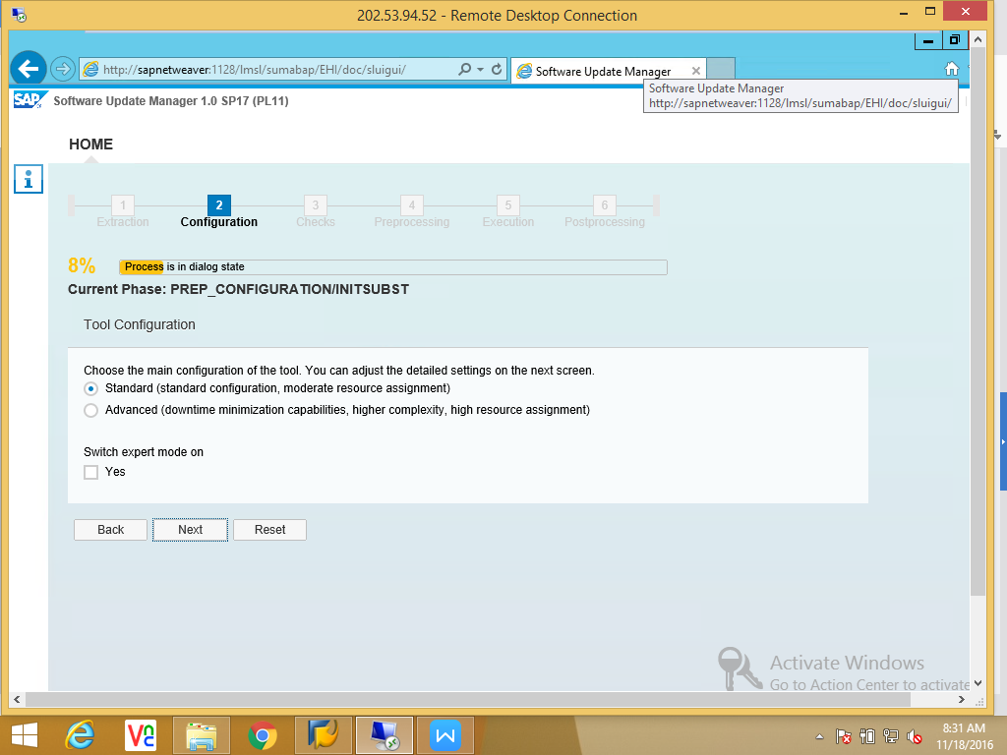

-->Define the parameters;
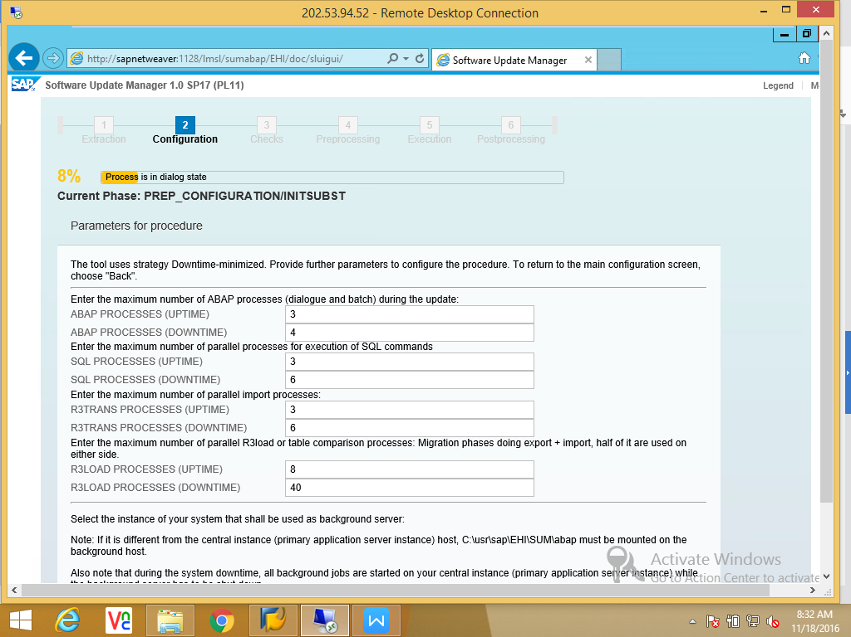
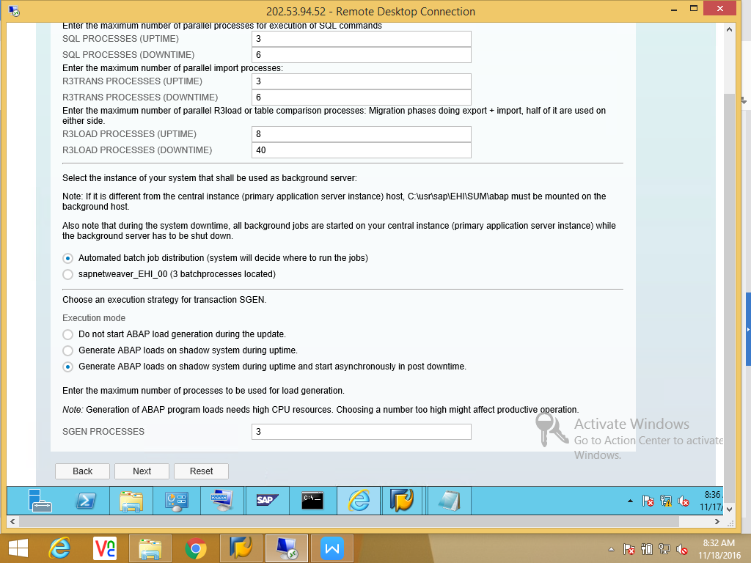
Reduce the R3loads 40 to 20.
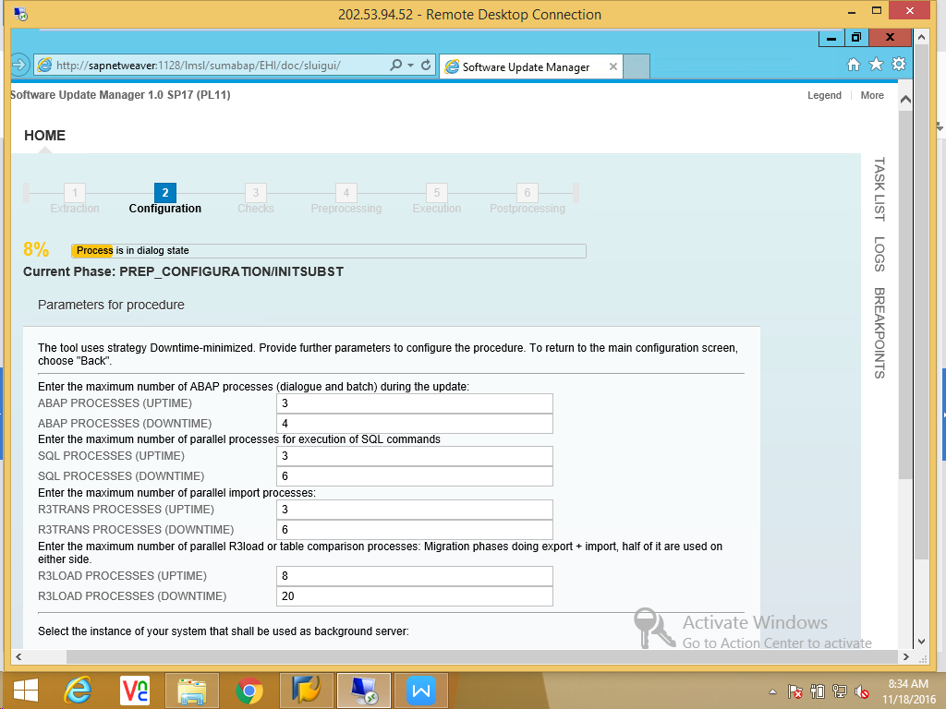

Do not generate SGEN.
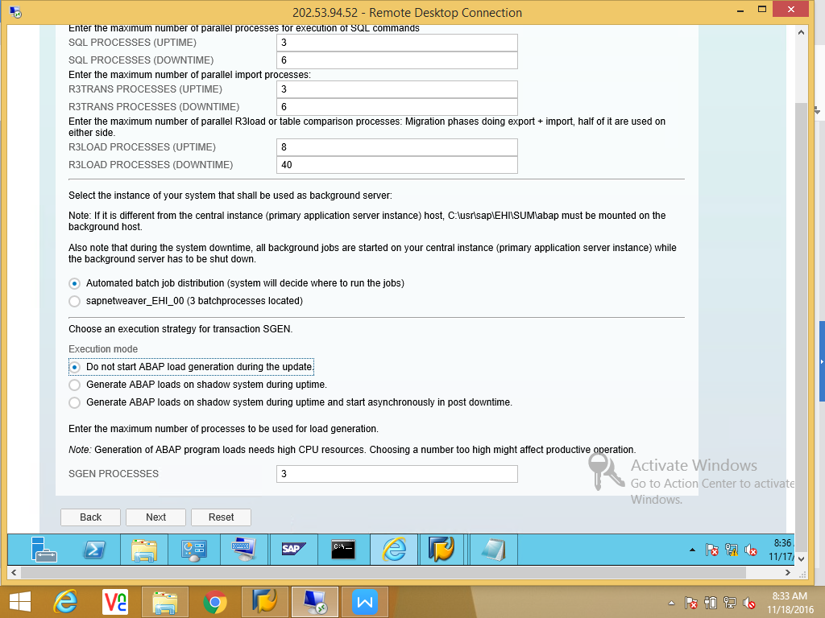

HANA DB Client path for windows.
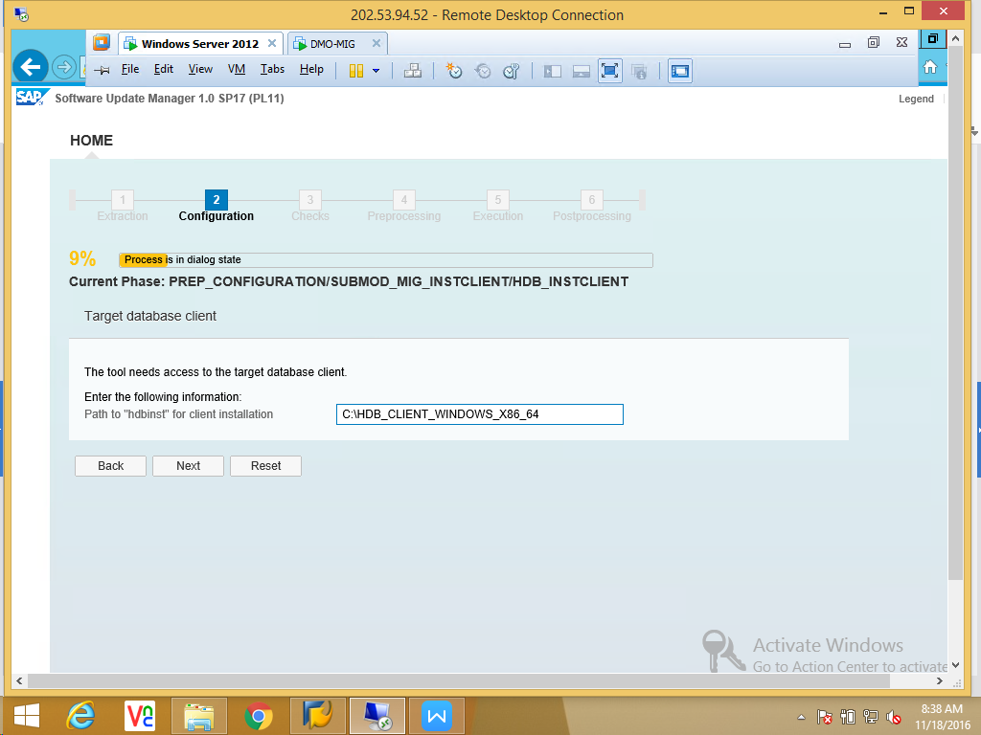

Source system sidadm pasword.
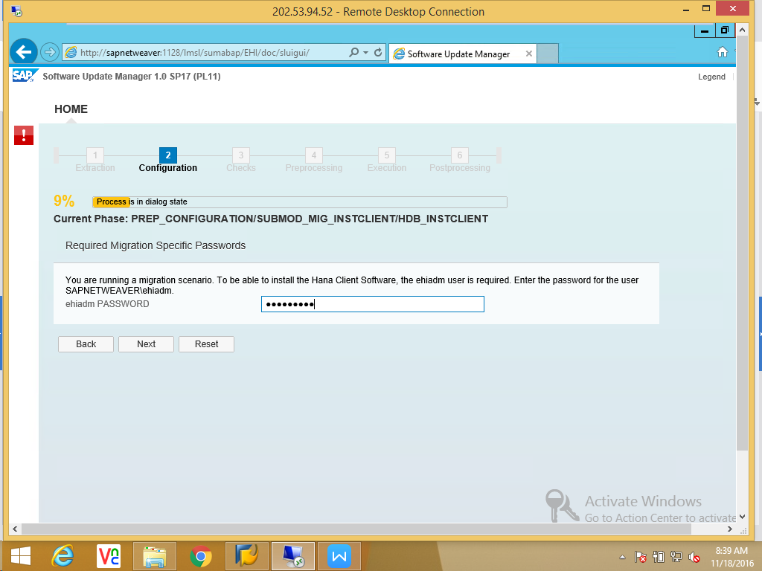

Provide Target HANA system hostname, instance no, SID, License.
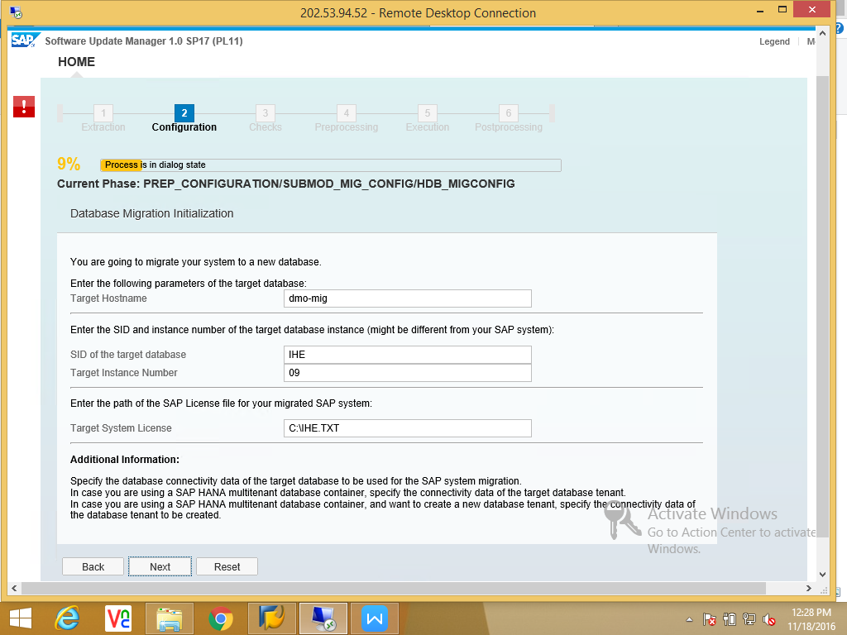

Provide HANA SYSTEM user password.
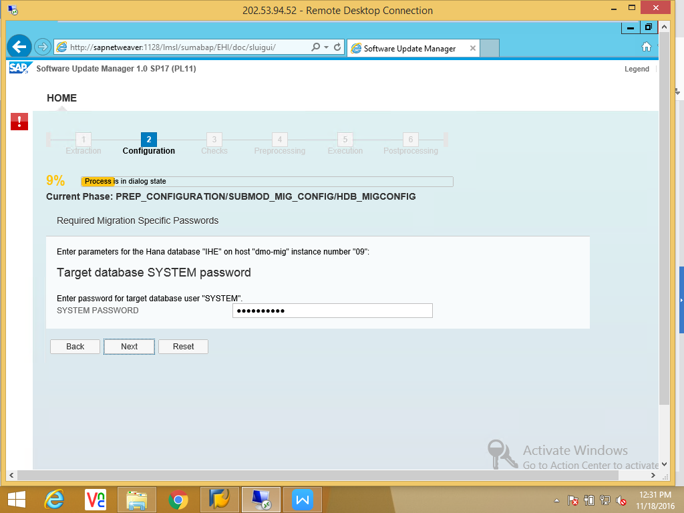
Hyder_786
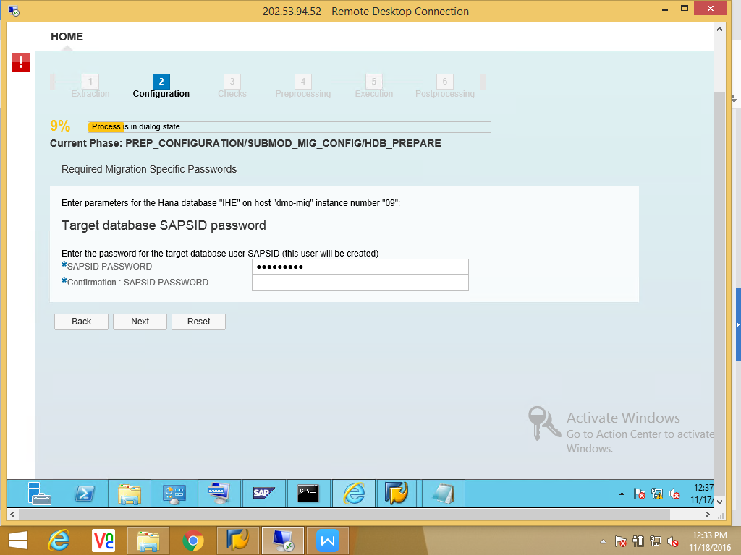

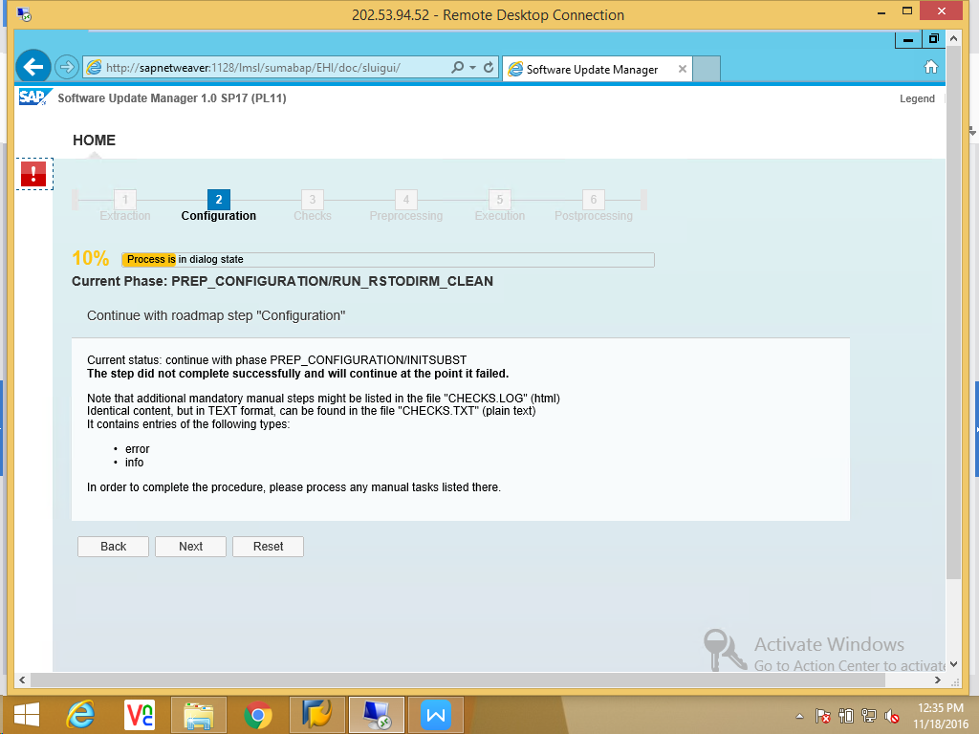

Error log:
- Missing notes
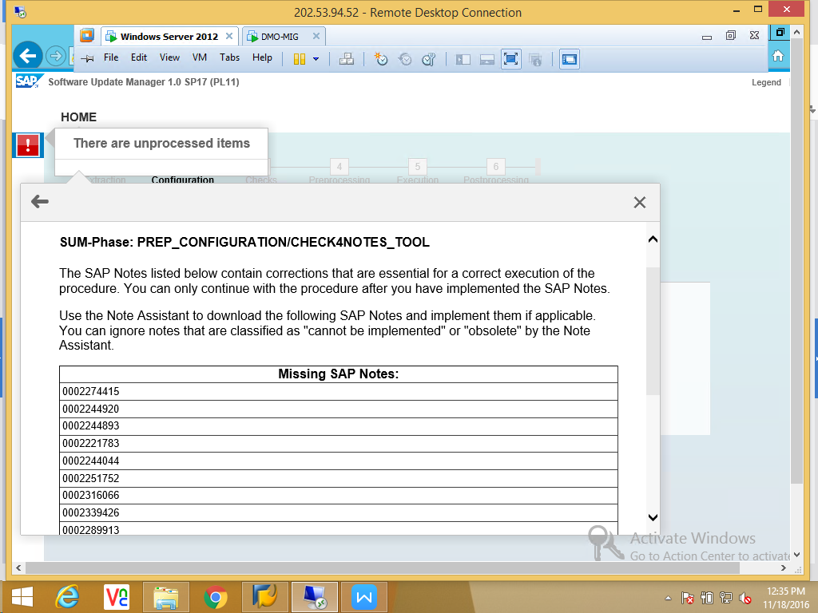

B) Time difference between source and target systems.

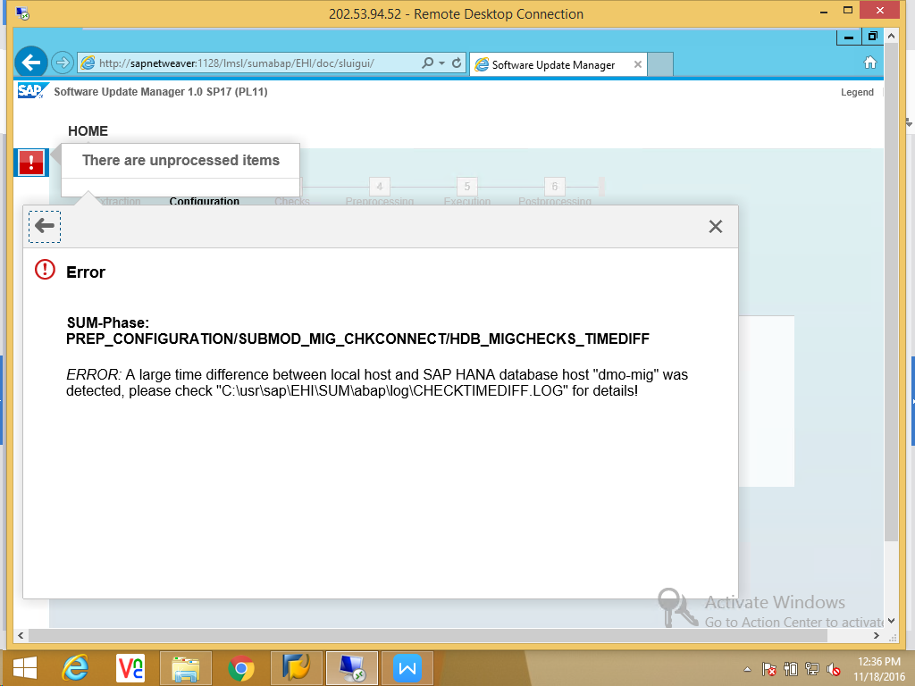

Apply notes
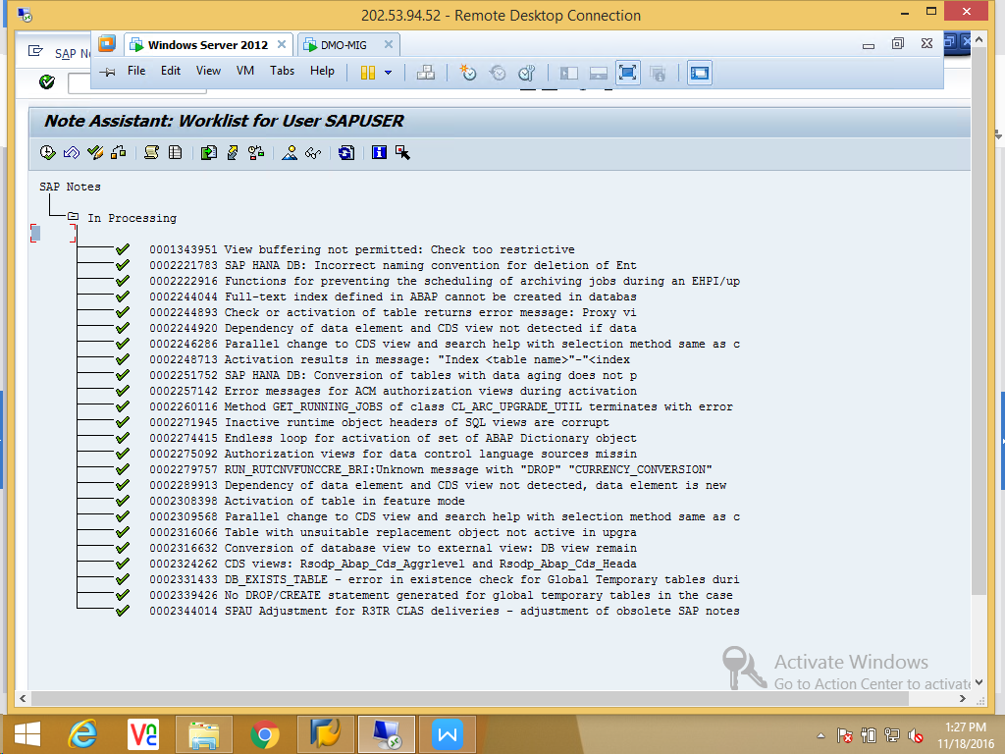

Release Transport request.
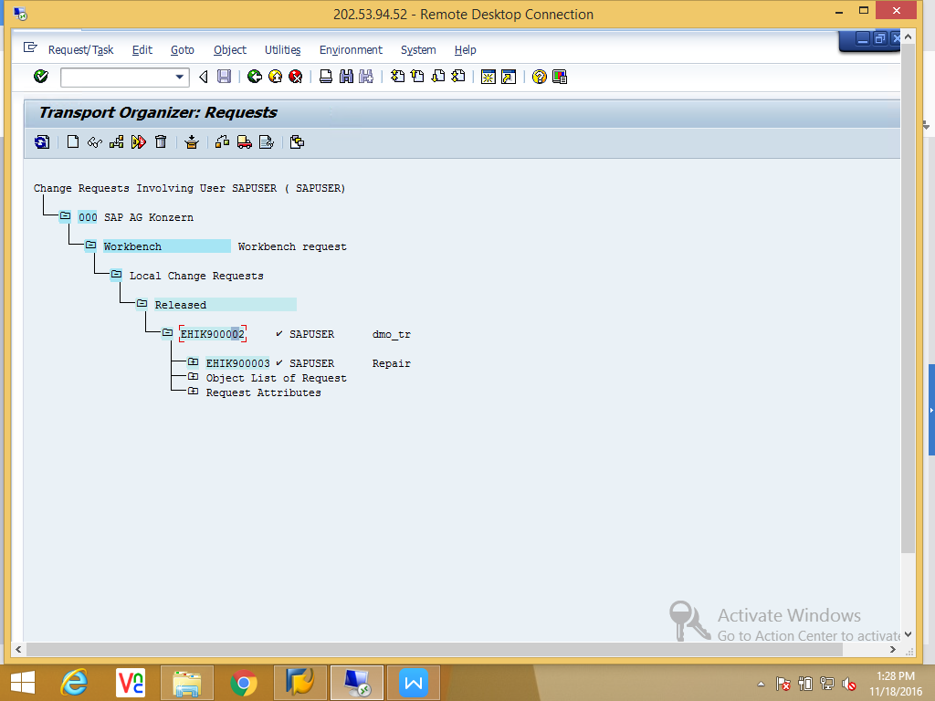

After Release Transport request and adjust time settings in both systems and continue.
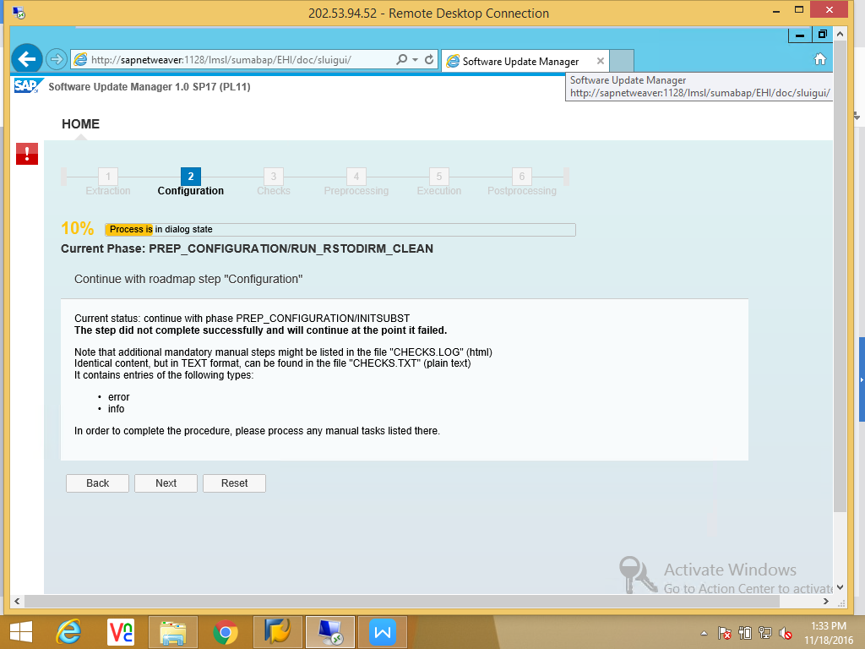

In this phase SUM checks the Source and target Kernels.

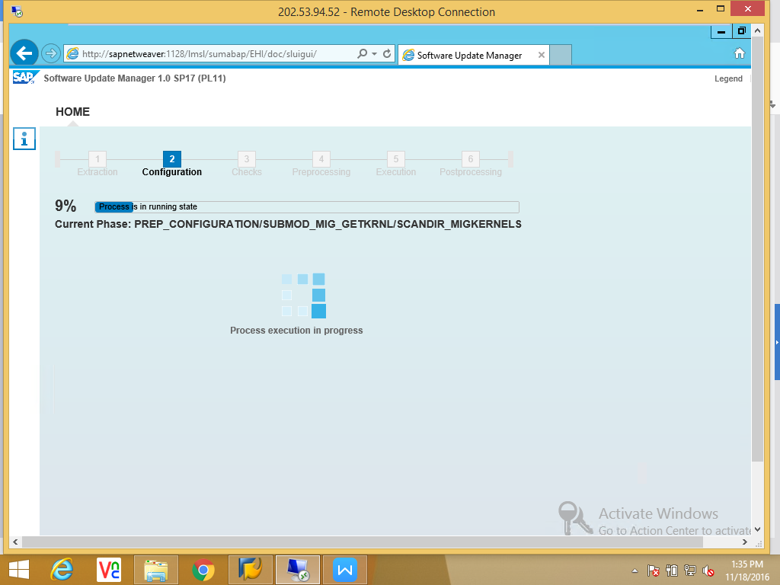

SUM keeps the Source DB in No archive mode. Click on Next to continue.

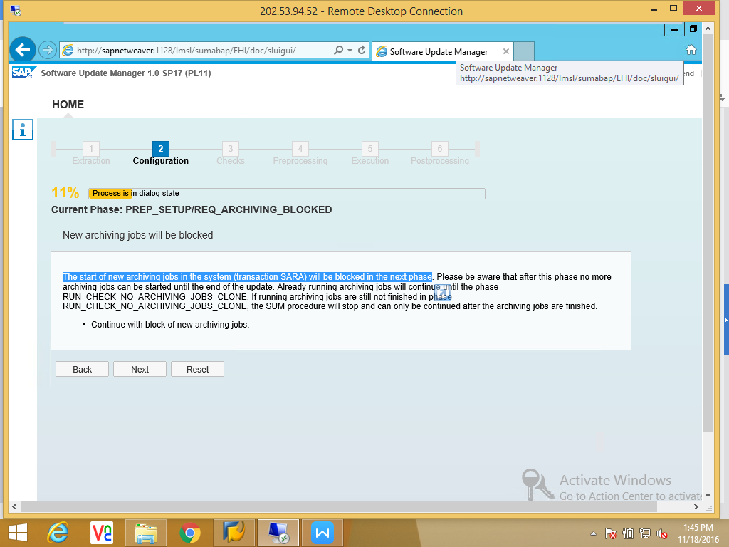

Following things are going in this phase.
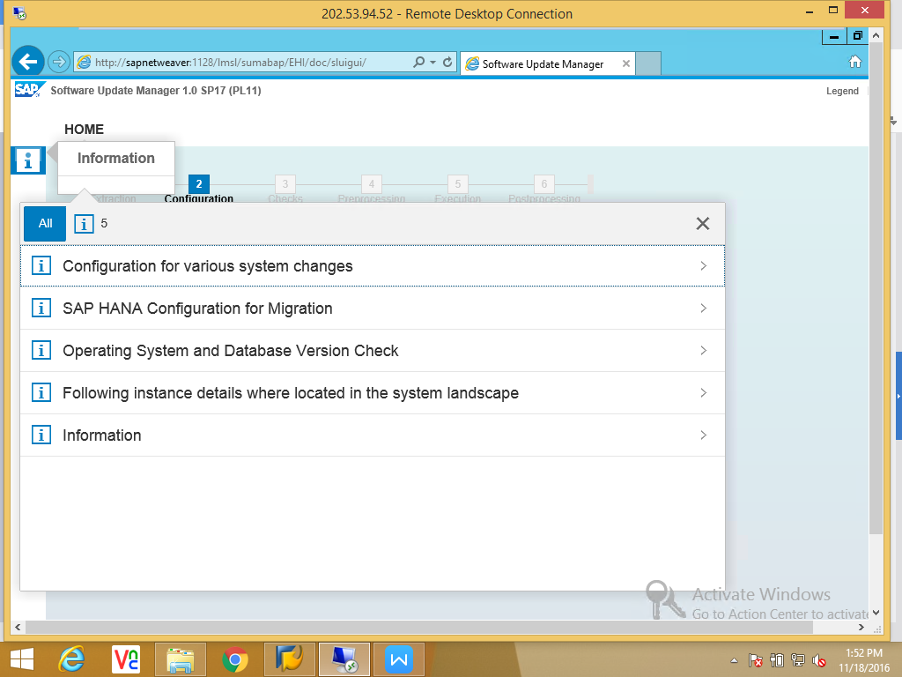

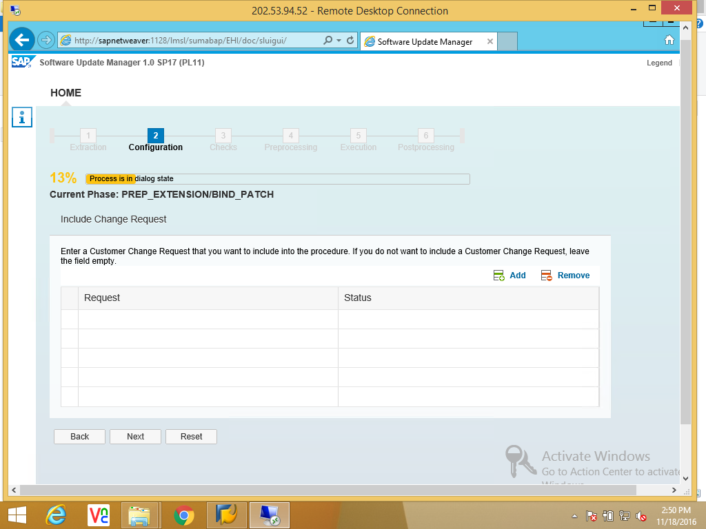

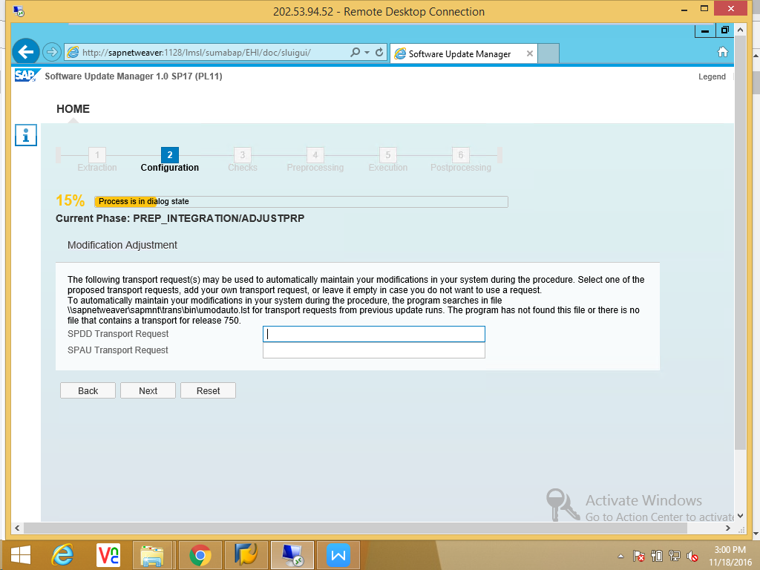

RUN_DBCLONE_INIT phase long running.

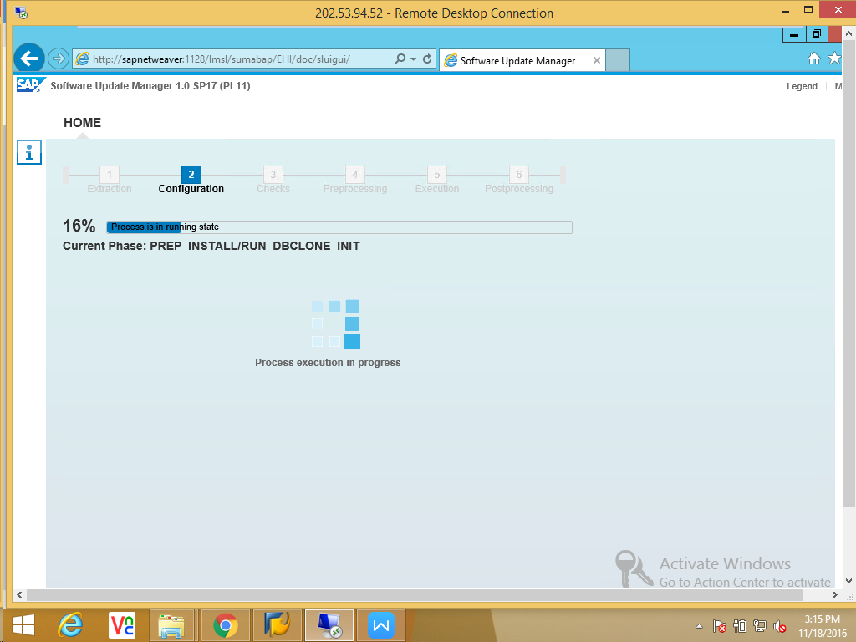

Continue to Next phase “Checks”.
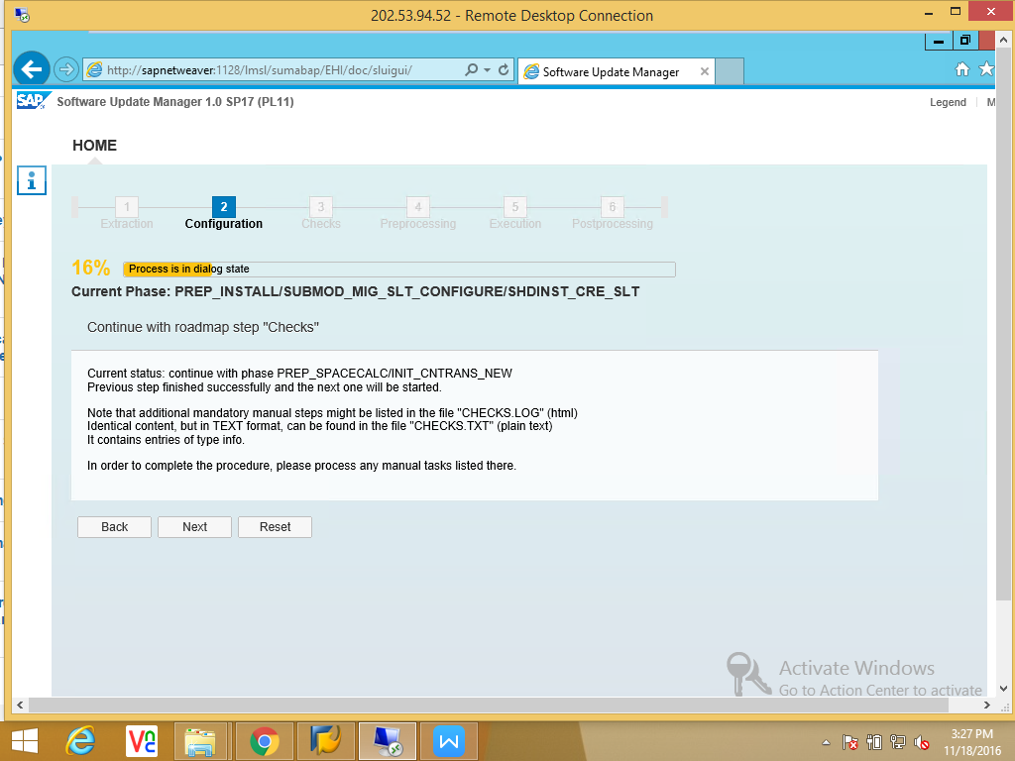

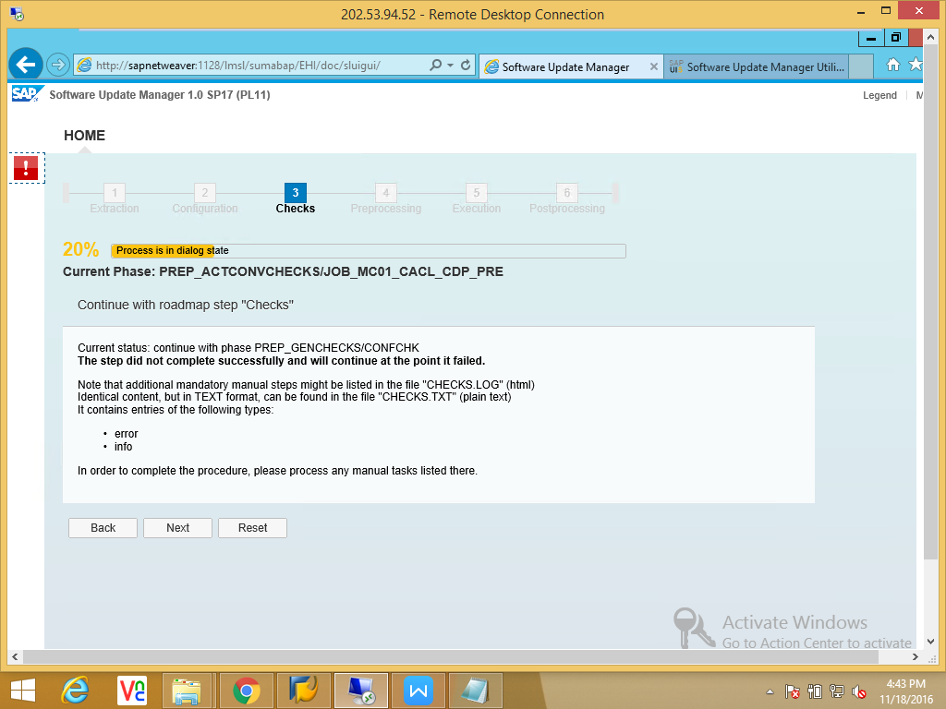

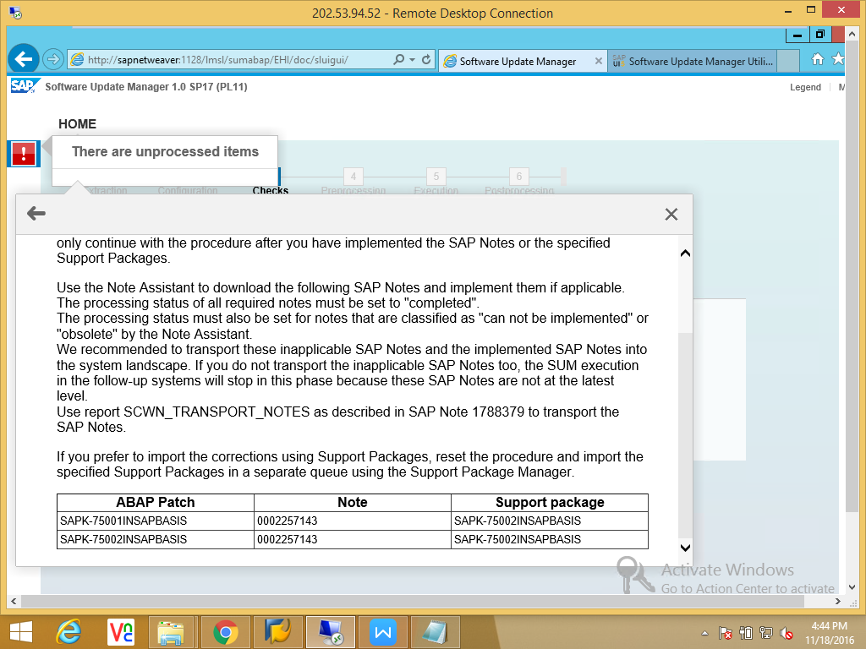

Apply the notes , Release the transport request and continue.
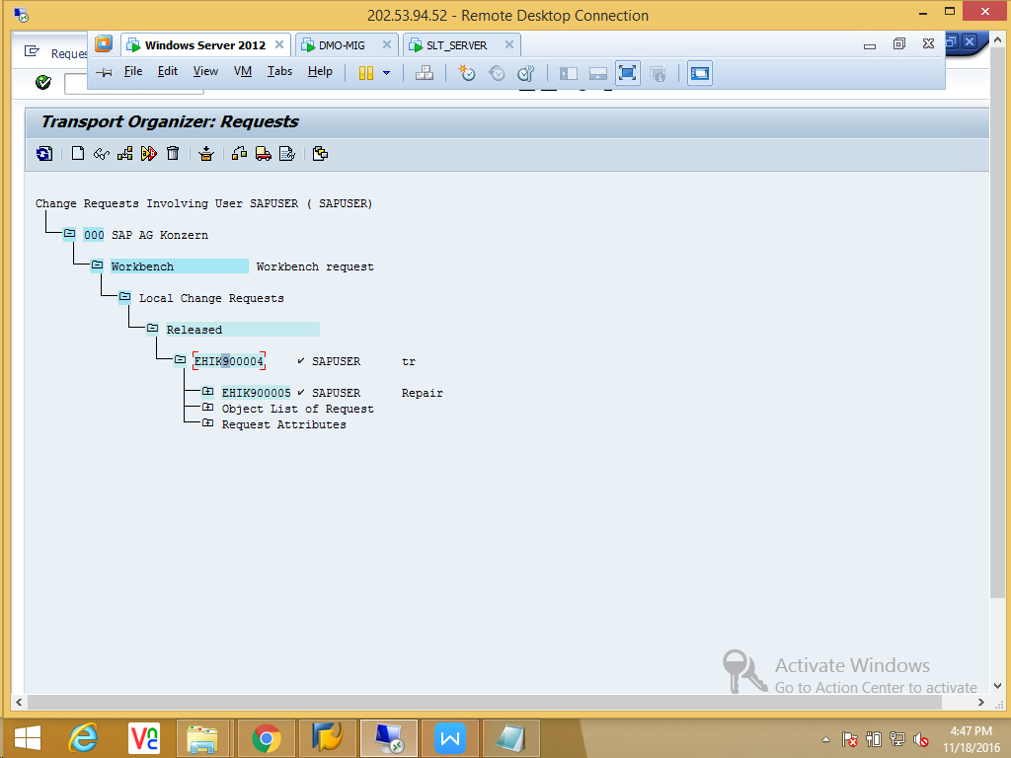

“Checks” phase Completed. Continue to Next phase “Preprocessing”.

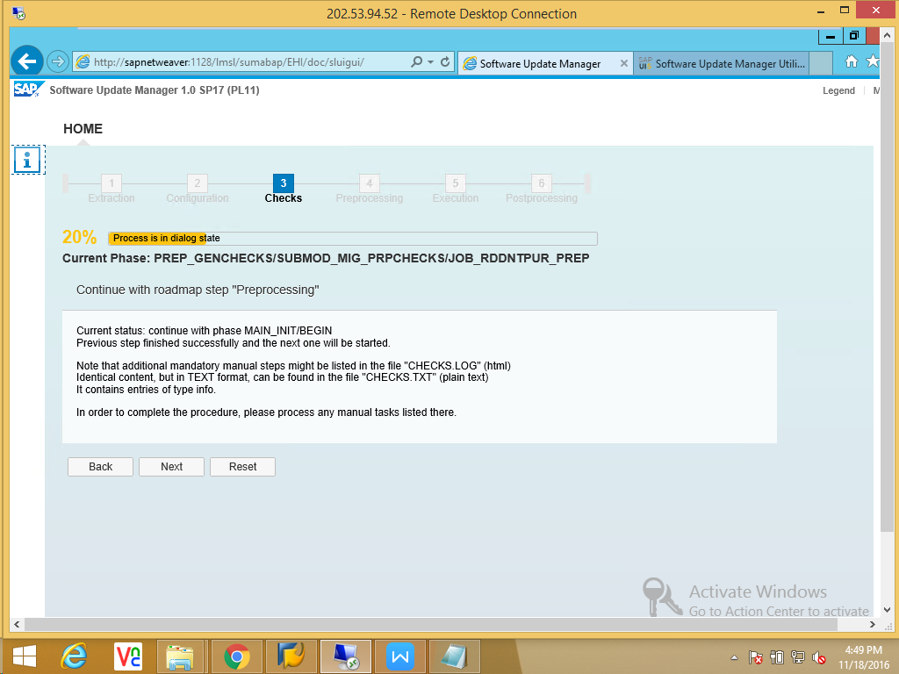

Lock the Development in this phase.
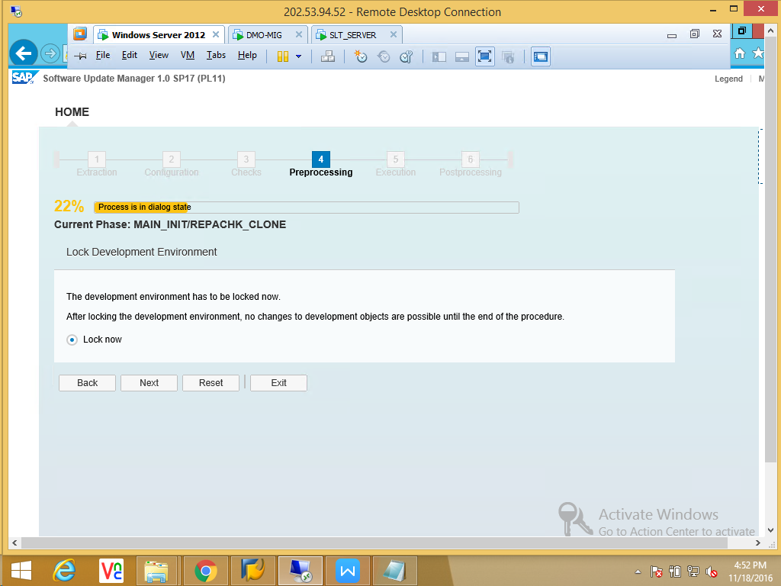

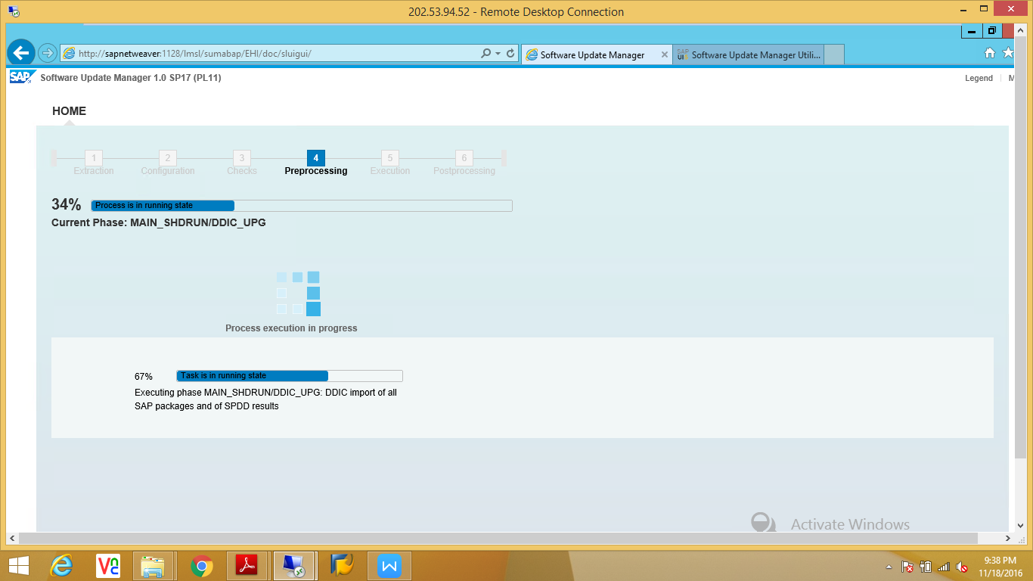

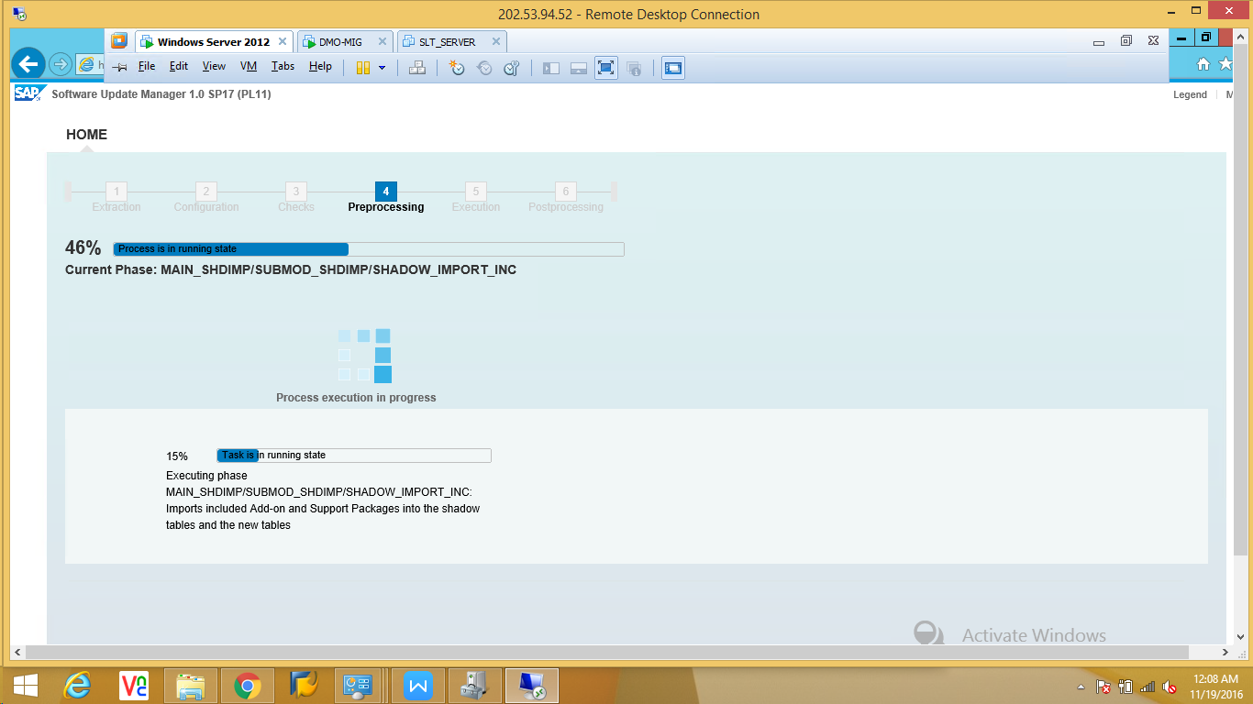

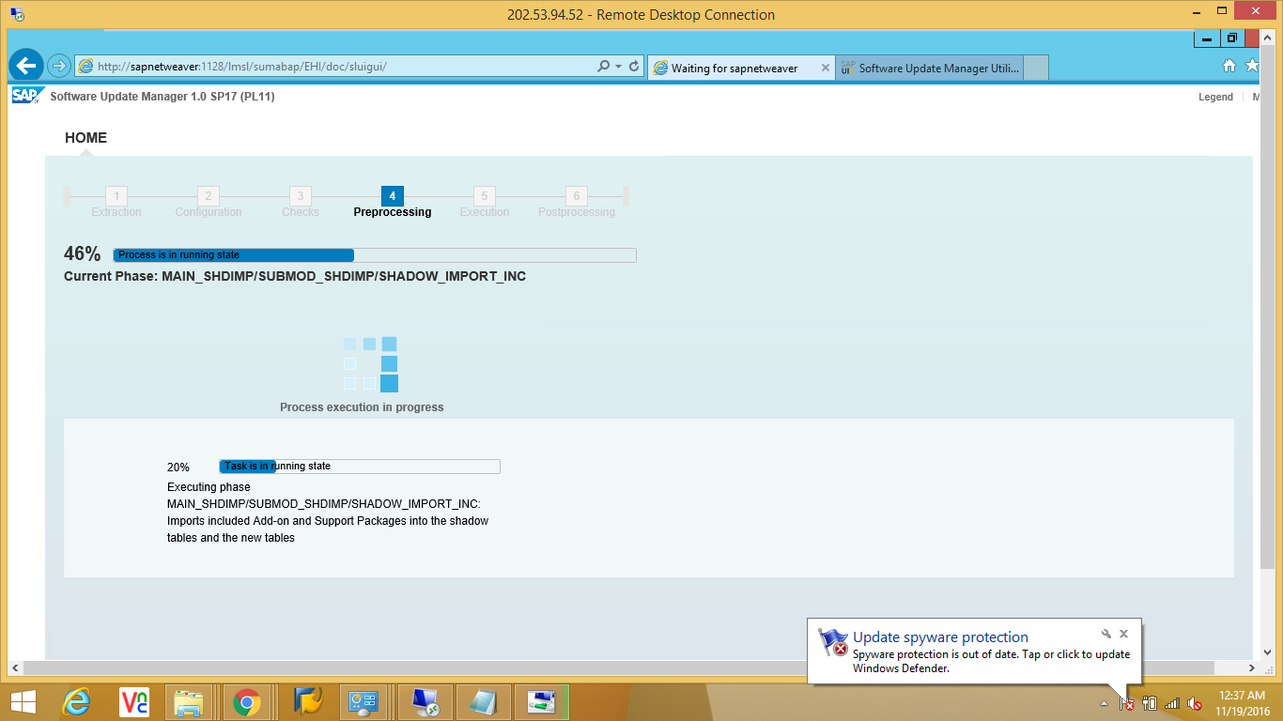

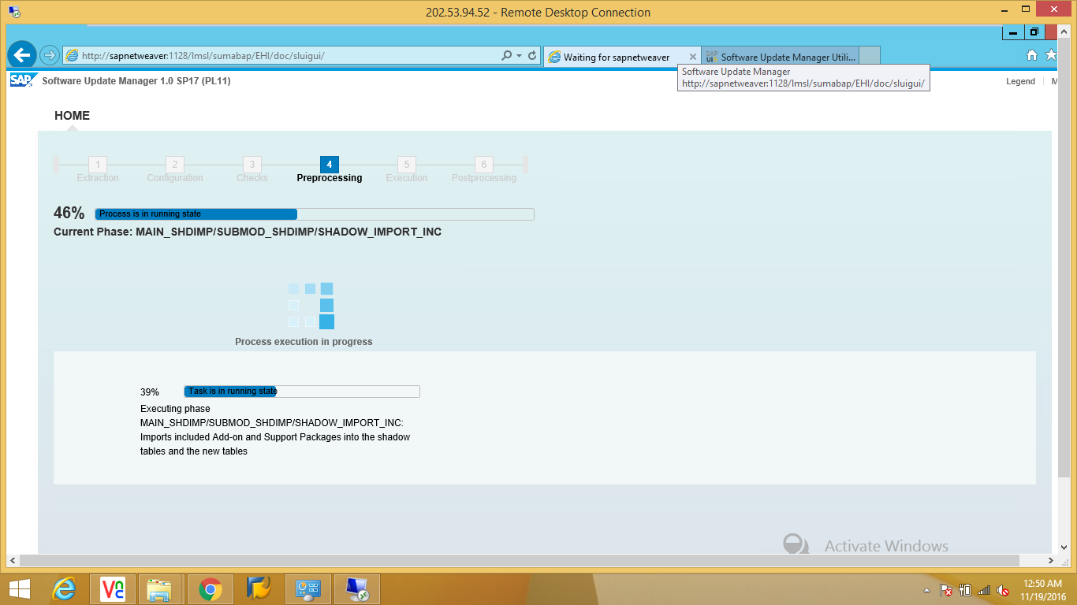

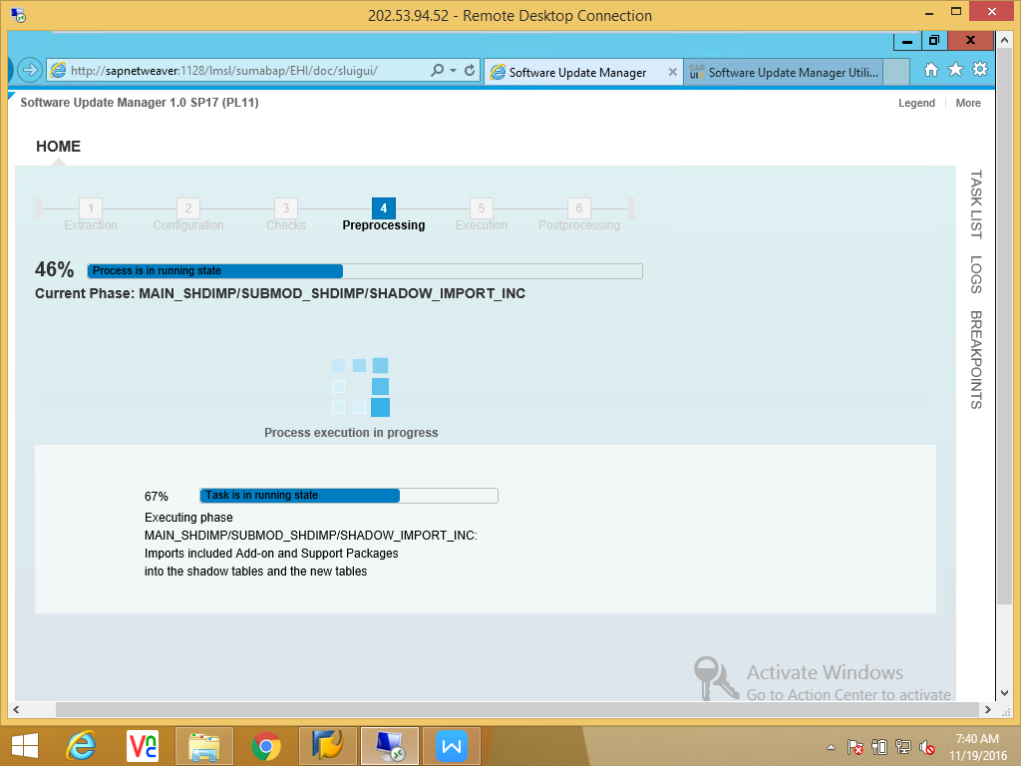

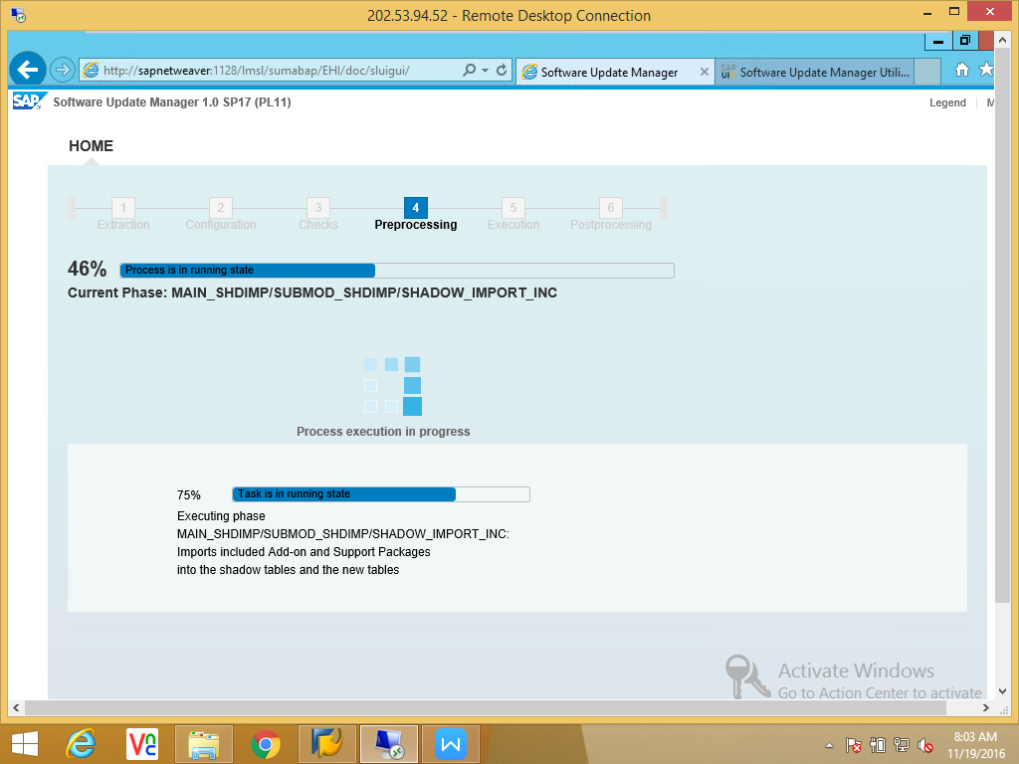

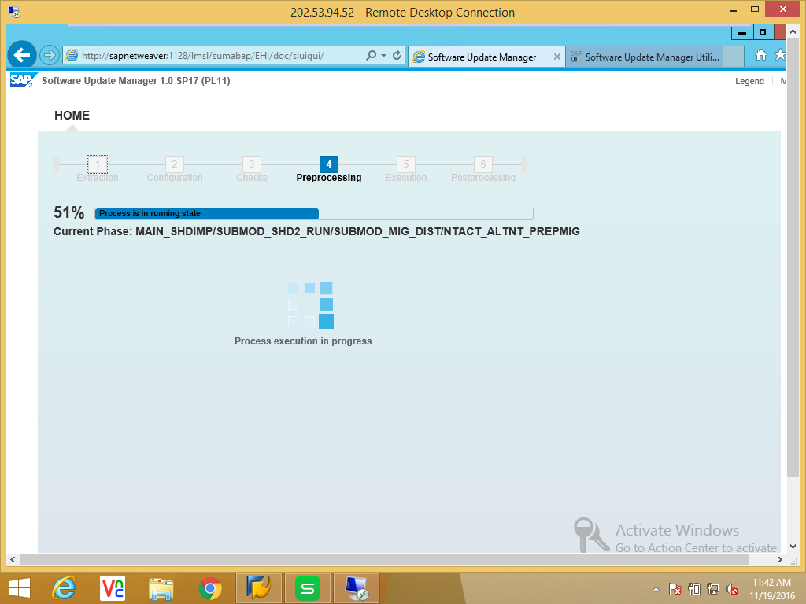

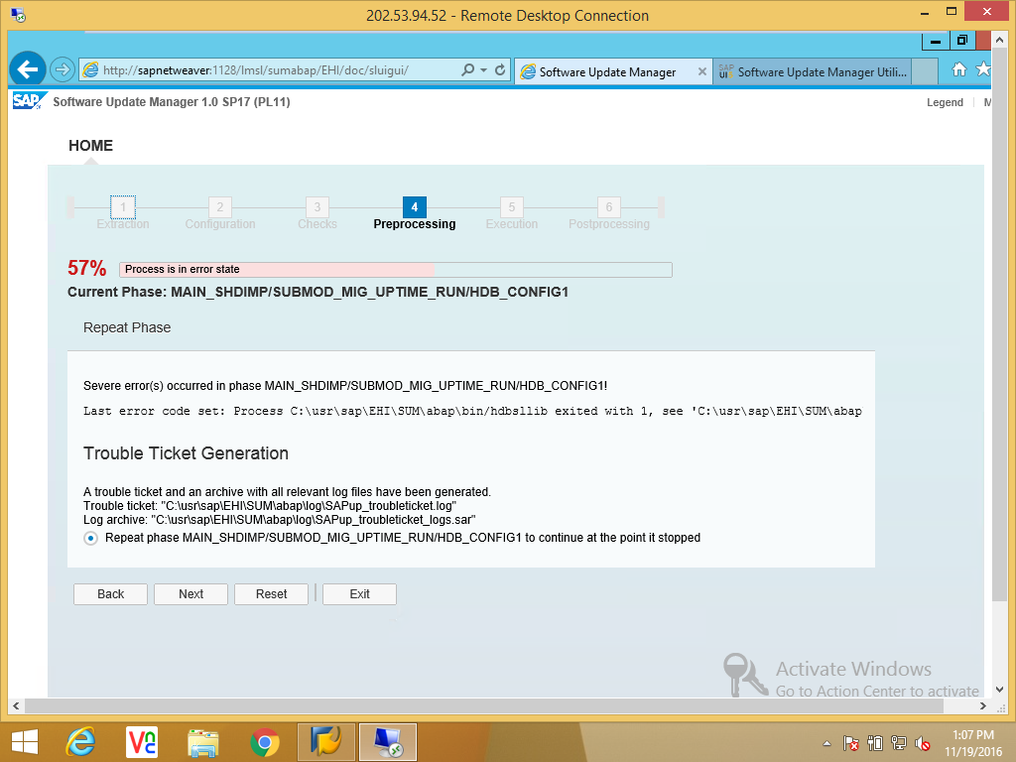

Error: SYSTEM User id and password mismatch.
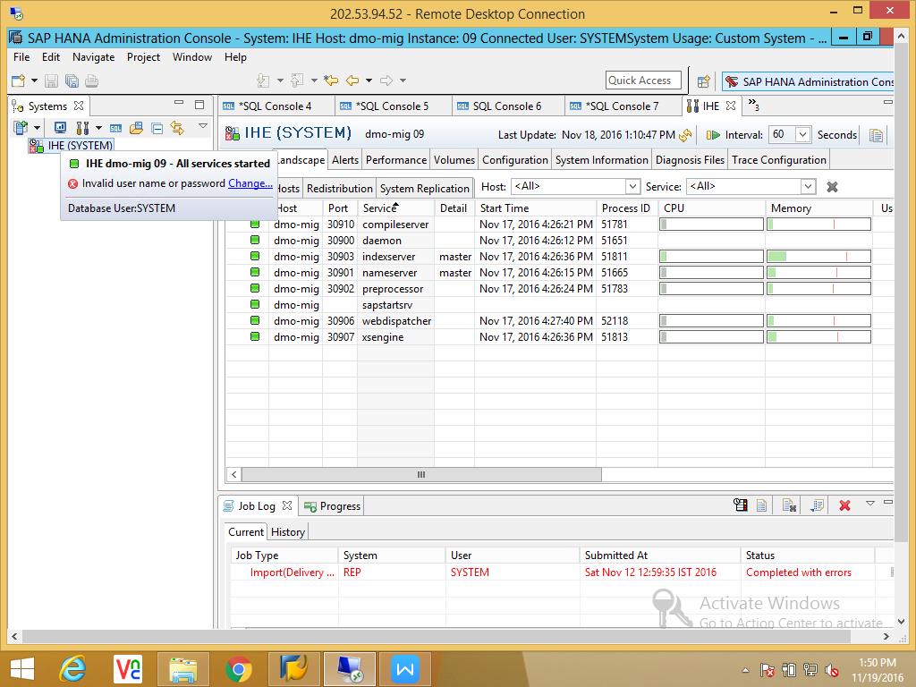
Reset SYSTEM user password and retry.
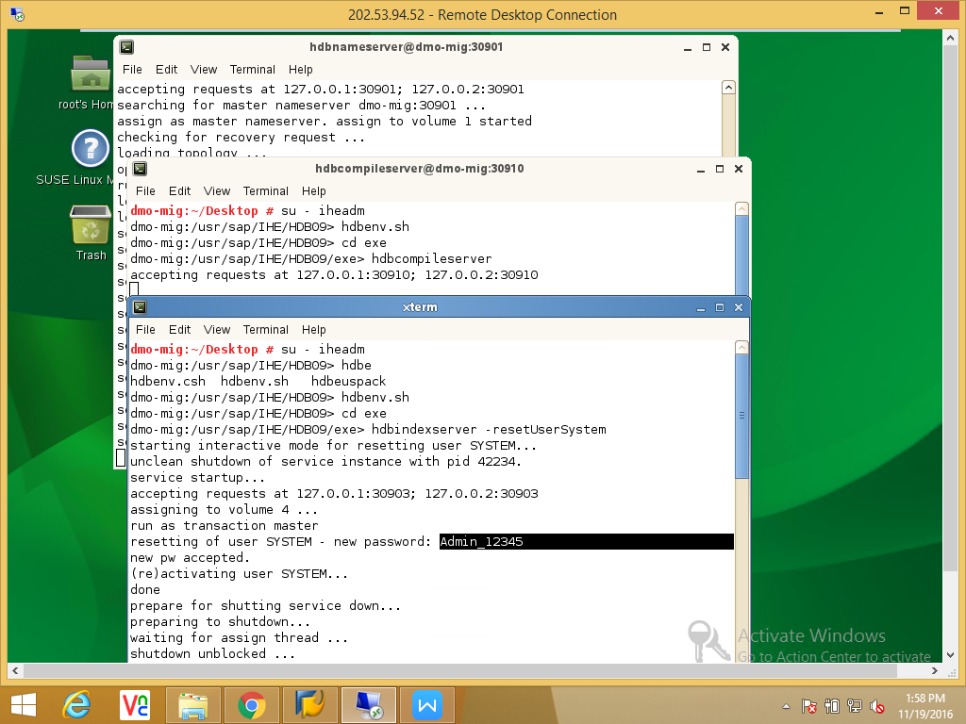

Start HANA services.
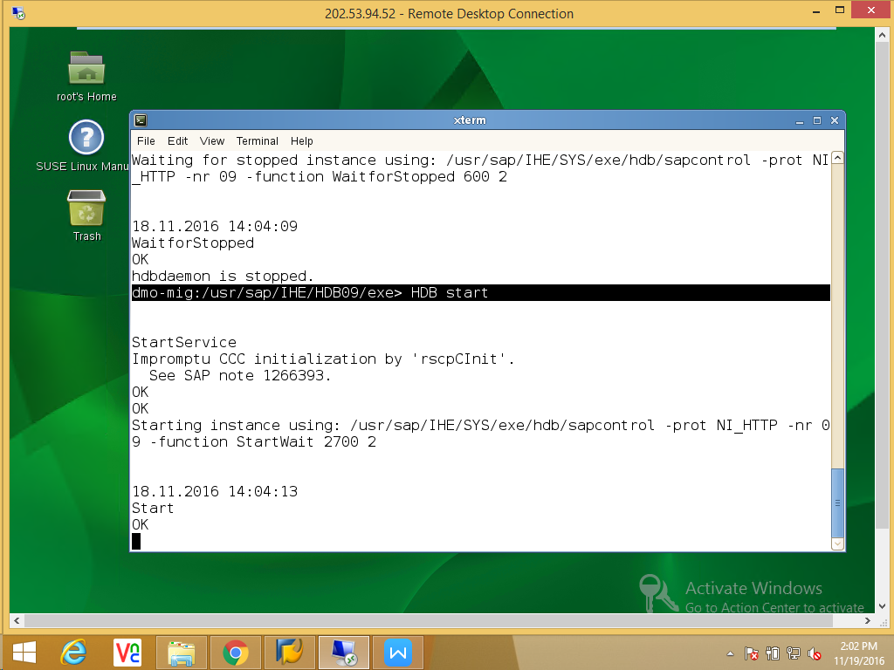

The actual issue was during the DMO procedure the HANA system user password is automatically changed. Also there is password policy that we do not use last 5 passwords. So we changed again and again and finally we Changed the SYSTEM user password which is given During the SUM Configuration Phase.

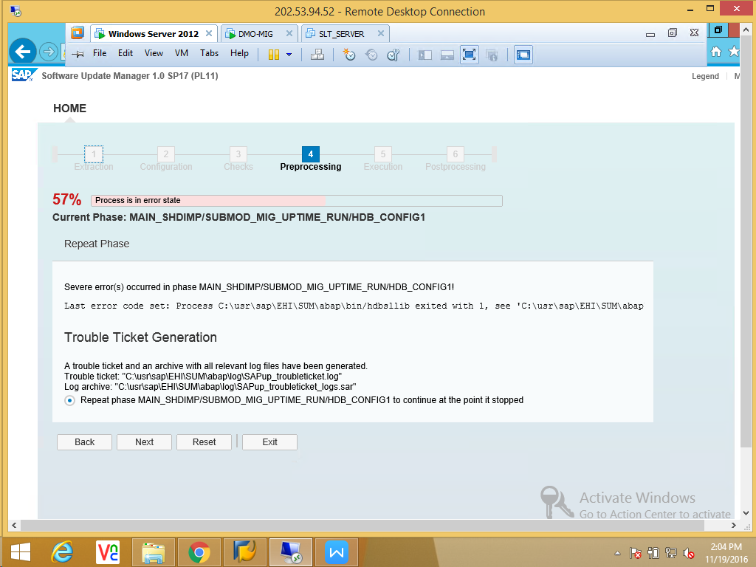

Admin_123456
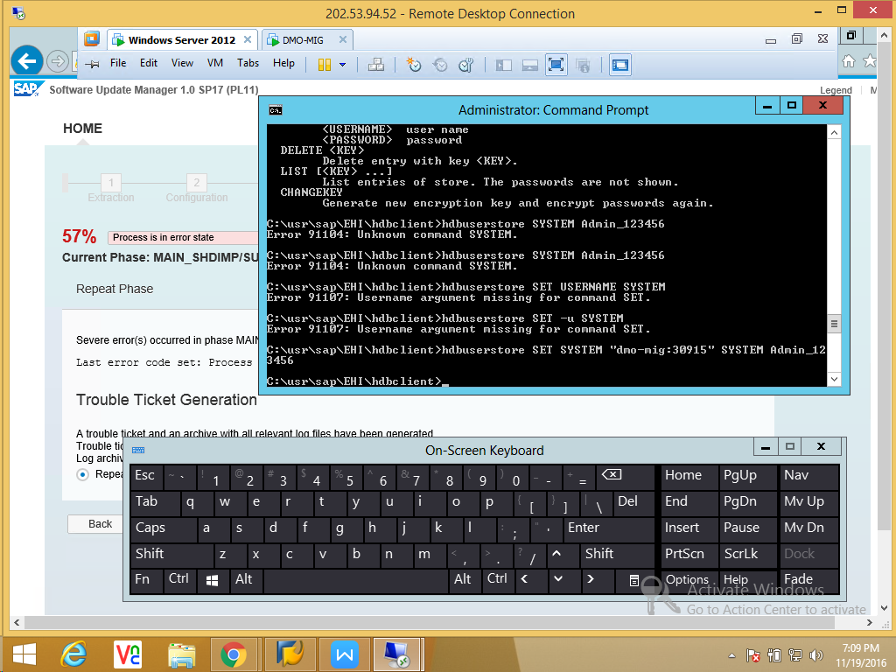

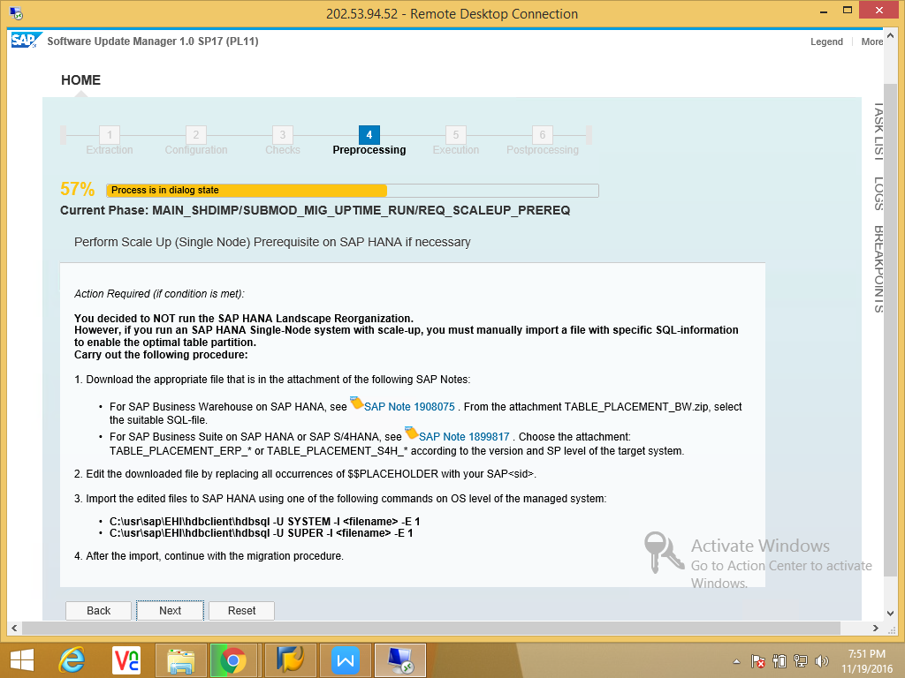

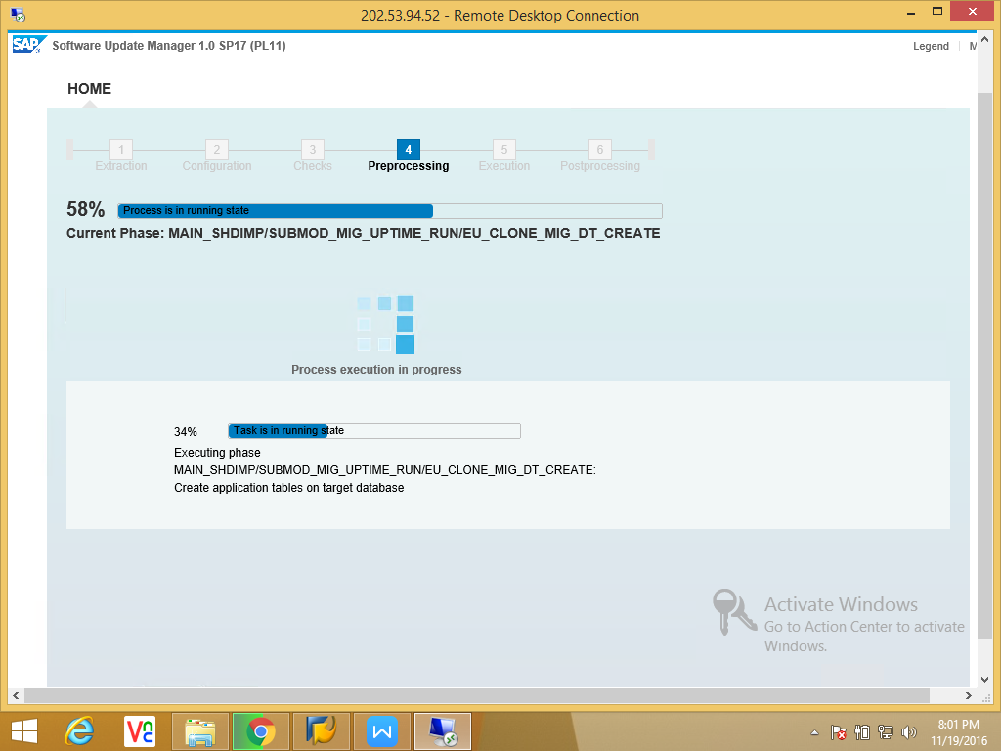

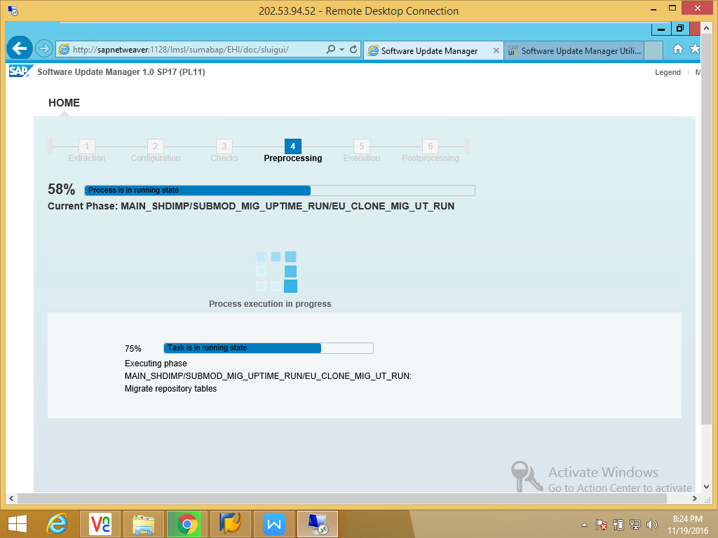

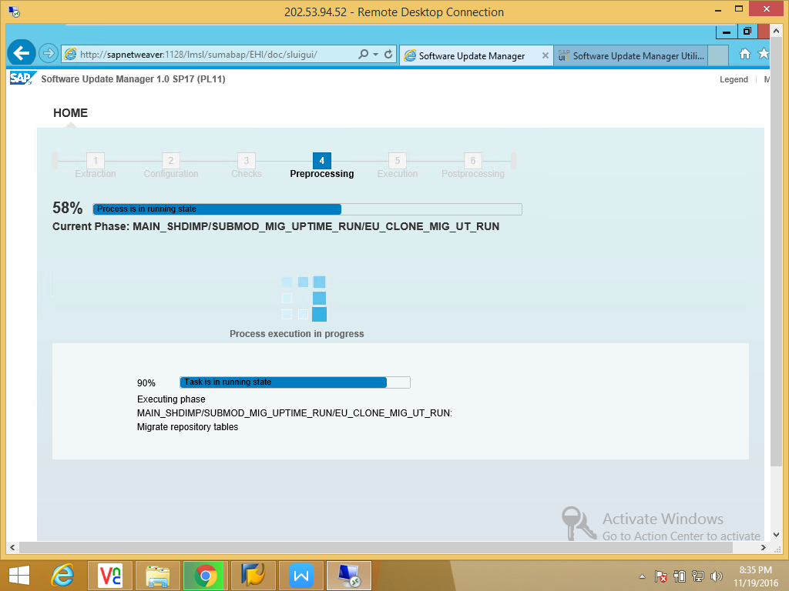

Stop the production activity.
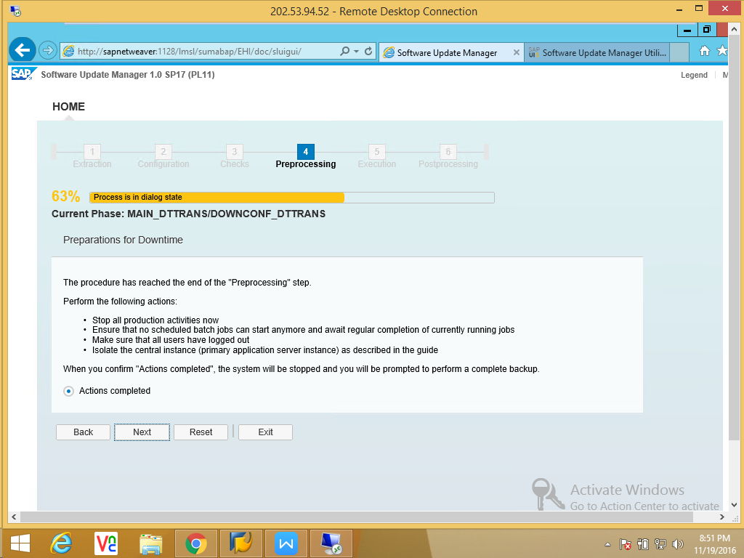

Application server is down automatically in this phase.

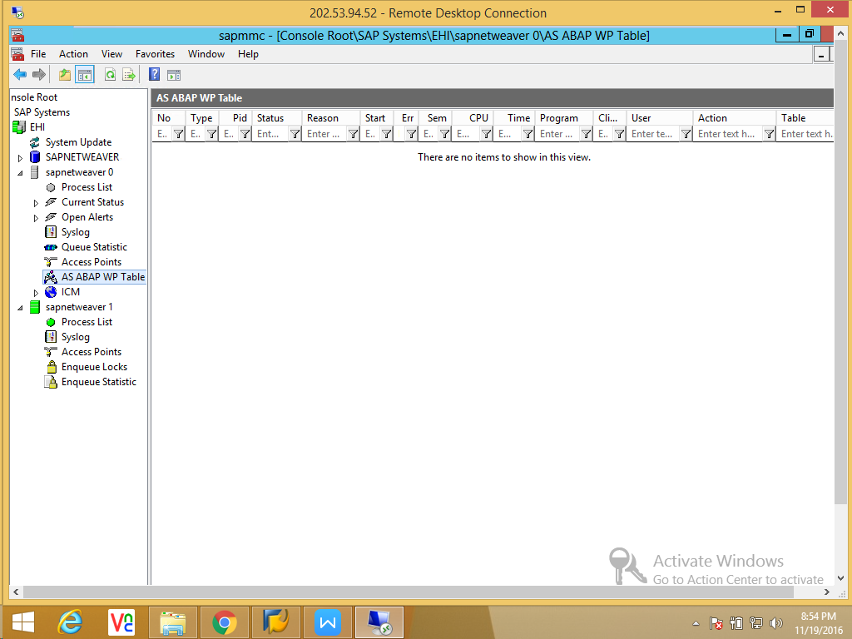

Make sure have a complete consistence backup for rollback.

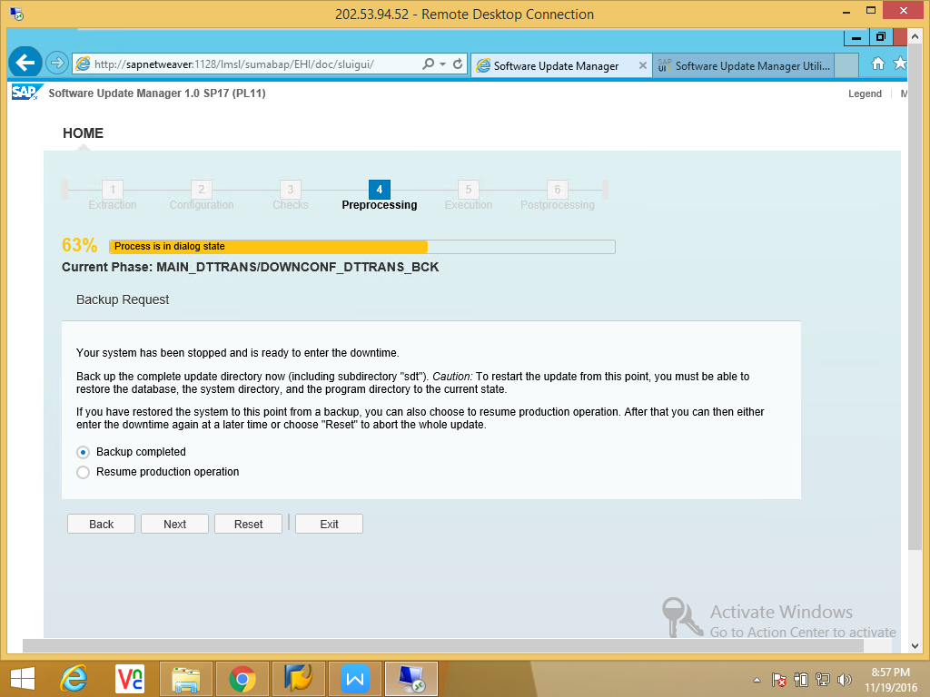

Preprocessing completed next to execution phase.

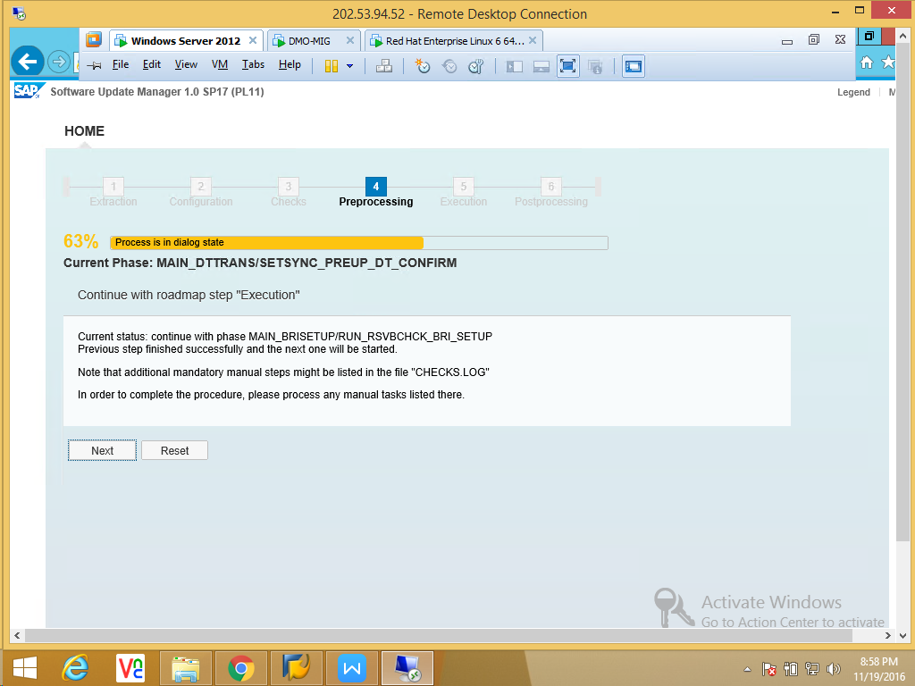

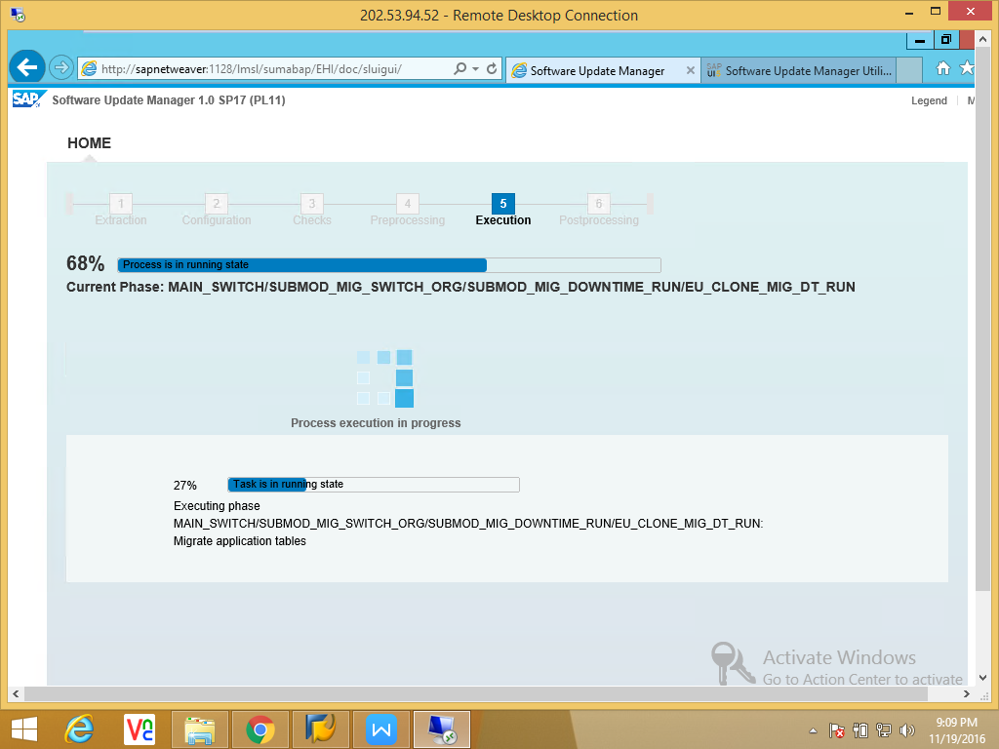
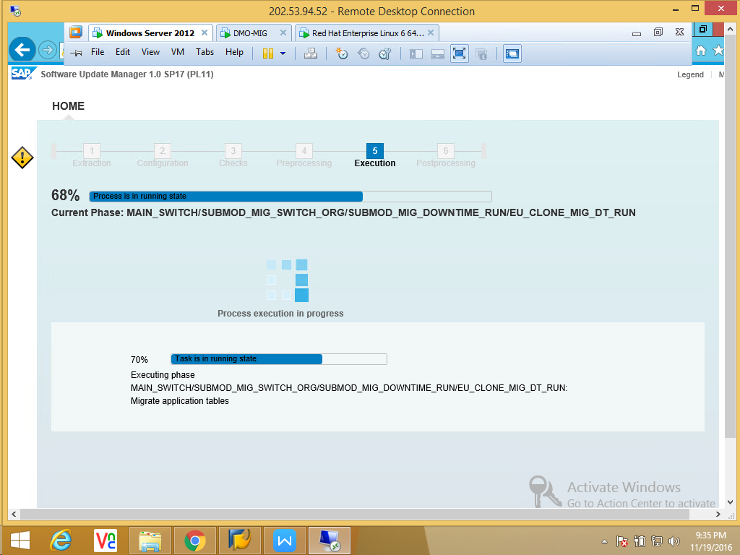

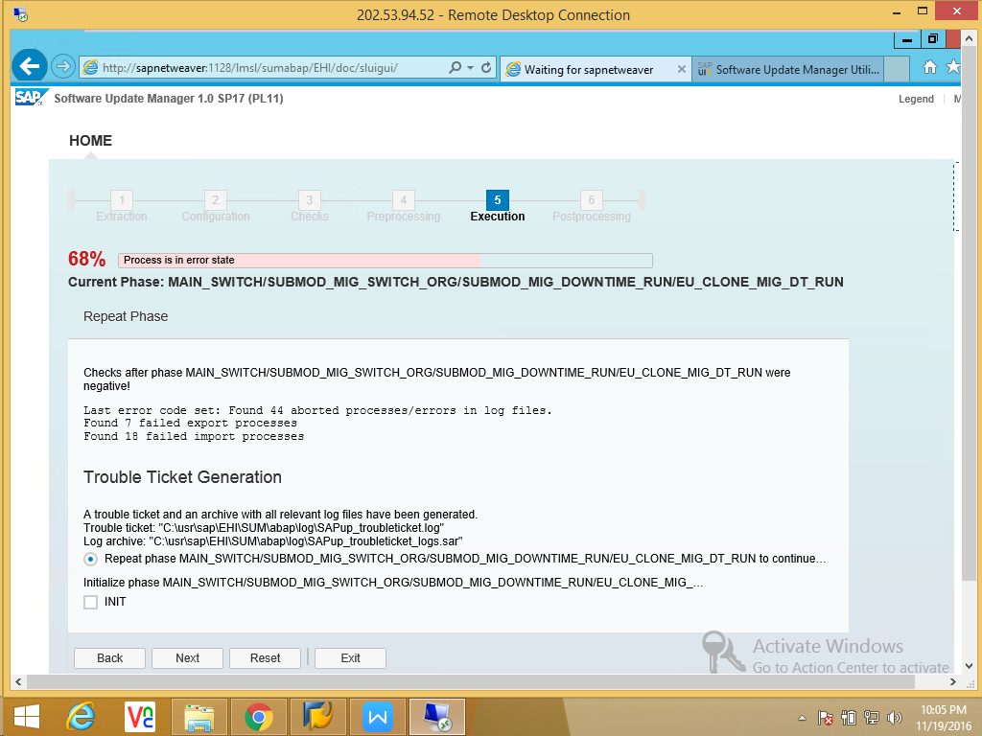

We reduce the R3loads and continue to next.
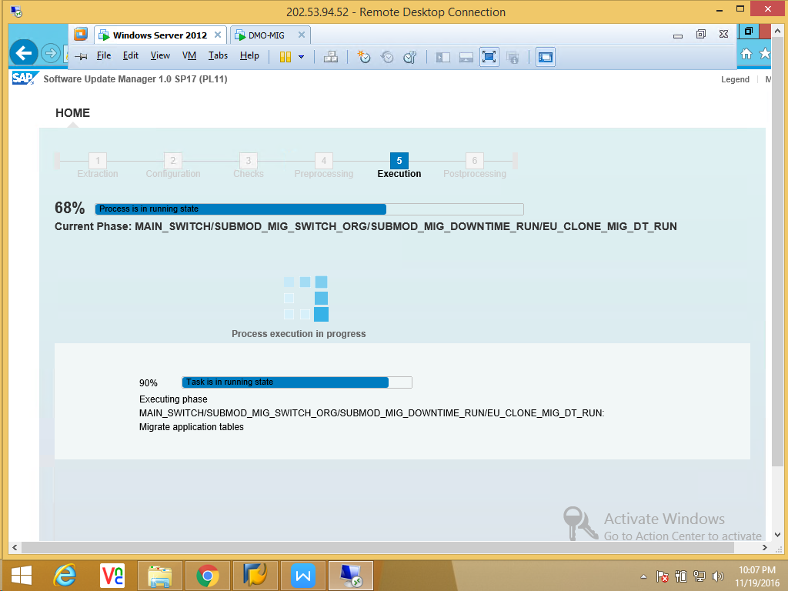
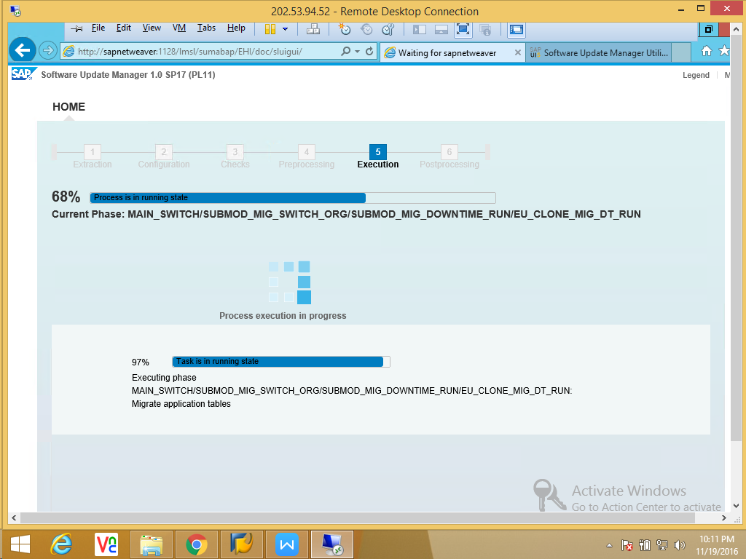

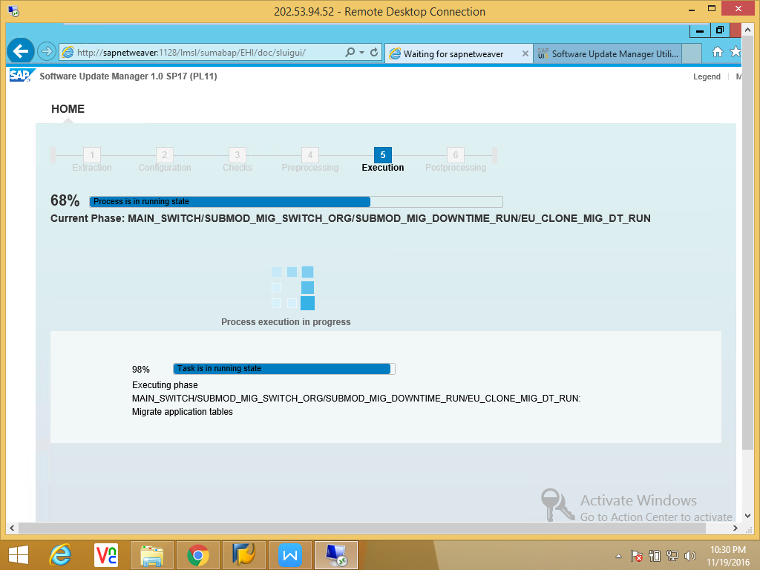

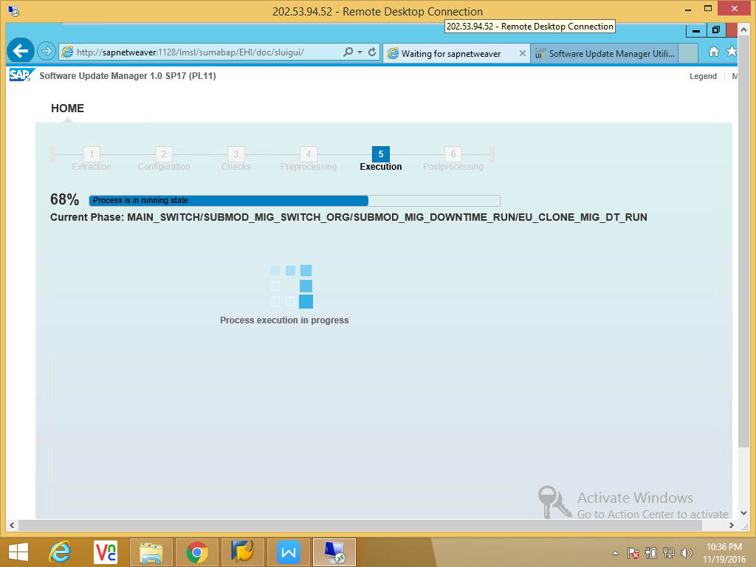

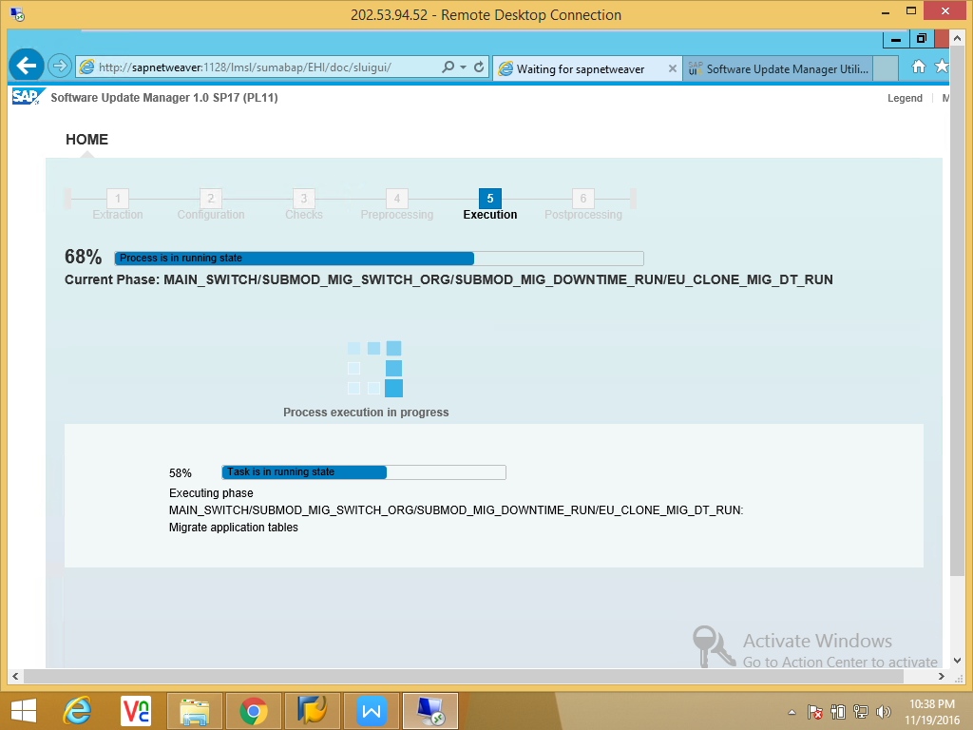

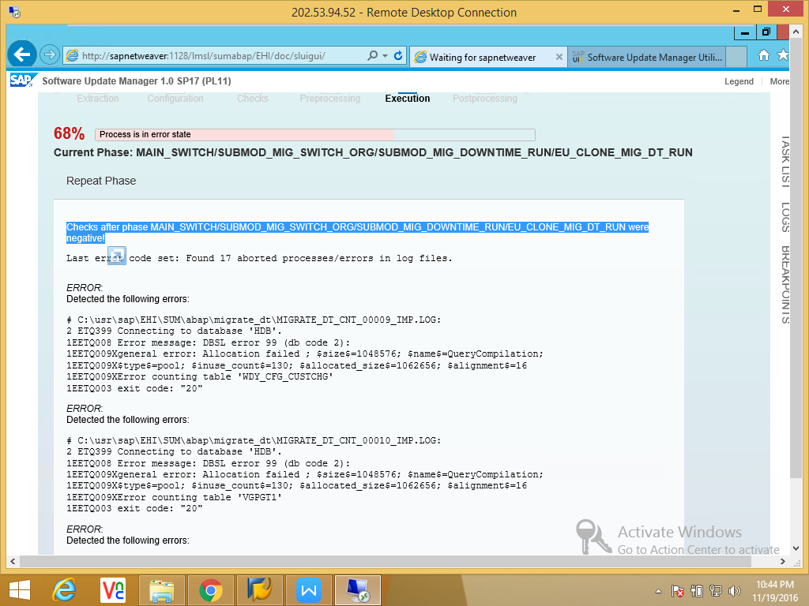

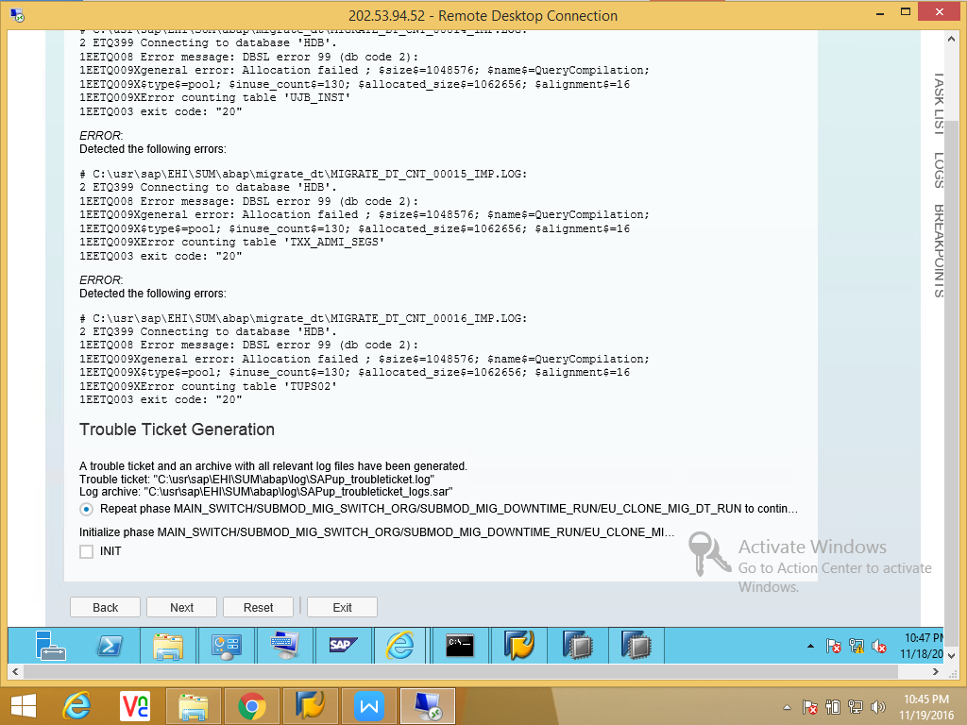

Tried with reinitialize phase.
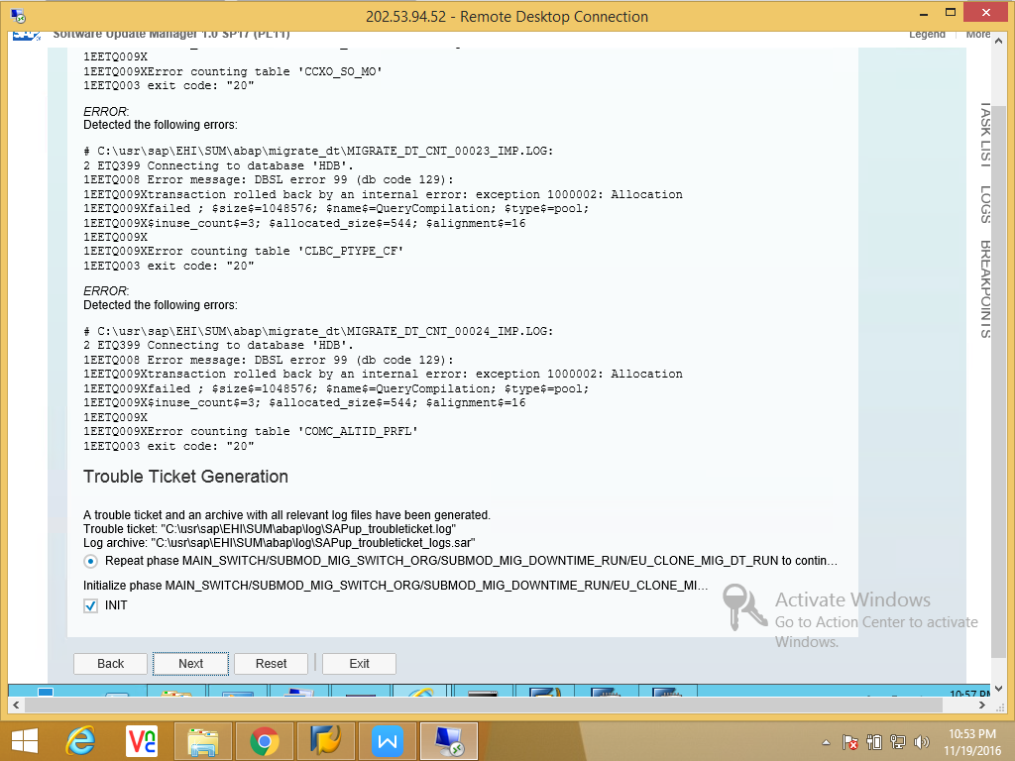

Updated R3load in exe and exe_2nd retried. Again same issue.

