SM50 Work Process Overview :
Work Processes are Monitored by using Various Tools.
1. dpmon (Dispatcher Monitor) It is an OS Utility provided by SAP to monitor the Dispatcher and Workprocesses. It is widely used on UNIX Platforms.
login as <SID>ADM and type command "dpmon pf=instance profile"
Type 'm' for Menue and select 'p' for process List and 'L' for Long Process List
2. These Processes are also Monitored at OS Level Using Command
'ps -ef |grep dw*' (on UNIX and Linux Environments)
3. They are Monitored at OS Level Using 'Task Manager'(Windows) .

4. They are Monitored by Using SAPMMC ( Microsoft Management Console), SAPMC(Management Console).
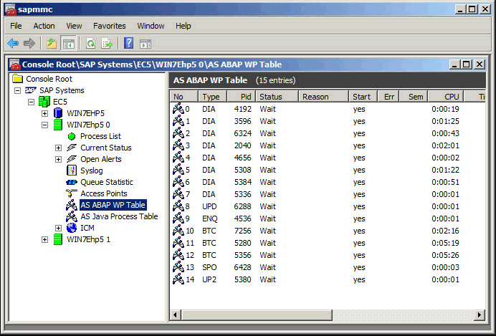
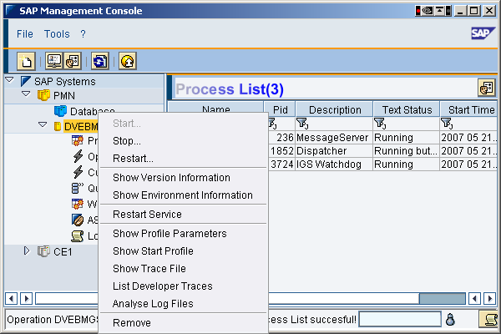

SM50 Process Monitoring:
- it is used to display the list of work processes configured on the Instance along with the type of Processes such as Dialog,Update,background,Spool and Enque.
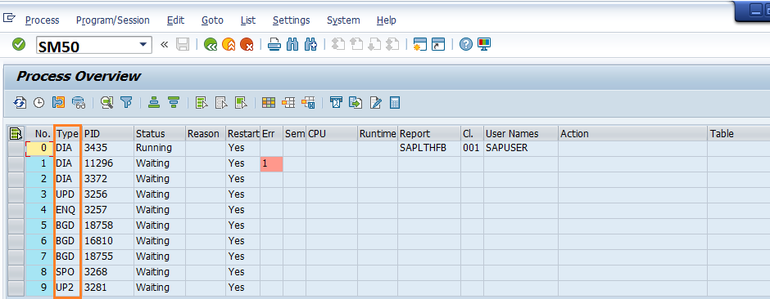
- It displays the serial number of the Processes that starts with ‘0’ where the process traces are displayed using dev_w0,dev_w1…..dev_wn-1.
- It displays the Process Type Along with the Process ID that is allocated at OS Level
- it displays the Status of the work process such as waiting ,running, stopped, on Hold and Ended.
WAITING: The Process is waiting to serve the User Request
RUNNING: The Process is executing(Processing) the User Request
STOPPED: The Process is stopped waiting for a Response from Internal or External Processes
On hold : The Process is stopped with Status on Hold for Additional Memory, or while in CPIC( CPIC is SAP Specific Protocol stands for Common Programming Interface for Communication) or RFC Mode
Ended: The Process is Terminated,Aborted, Cancelled, Failed etc..
- If the Processes are “on hold “ Then it displays the Messages such as waiting for Gateway,Message Server,Enque Server,RPC,ARFC,Heap Memory,Number Range etc.
- It displays the Restart Mode for each Process either YES/NO. Default Mode is “YES”. if the Process is terminating more Frequently then the mode can be set to NO to debug the Error Situation.
- It displays “Error/DUMPS” which specifies that process has been restarted/Failed. Precisely the Number of times the process has been failed.
- It displays the Number of Semaphore that blocks the Work Process. If it is in Red then it is Requested Semaphore(waiting),if it is Green the Semaphore is in Possession(Locked Semaphore)
- CPU time: The Cumulative CPU time.
- Time: The Time Consumed by Process referred as Runtime.
- User Name: Name of the User
- Program: The Name of the Program/Report
- Client: The Logged on Client Number
- Action: The Type of Action(read,logical read,sequential read,insert,delete, roll-in/out etc)
- Table; Name of the database Table
- Gateway and Message Server are not displayed in SM50 and they are maintained through separate Transactions because they are not internal to process the user Task.(SMMS for Message Server and SMGW for Gateway Monitoring)
Monitoring:
as part of the Monitoring Identify the Expensive Processes/Users along with their run time and Update the Check List.
Based on Approvals /Situation/Requirement the work process can be Killed/Terminated using SM50/DPMON tool in the following circumstances.
- When the process is consuming more Time
- When the Processes are in the Private(PRIV) Mode
- When the Processes are in the Stopped Mode Expecting a Response from the Target System with Reason (RFC,CPIC,RPC etc). The Expected Time elapsed.
- When all the processes are in the Running State,the system will be congested and based on time the processes are terminated
- SM50 to kill the Process(With Core Writes trace in work Directory)
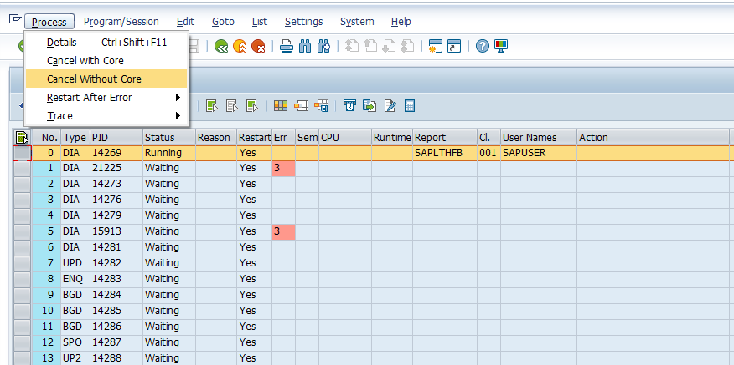
- When the processes could not be killed using SM50 then Use DPMON to Kill the Process
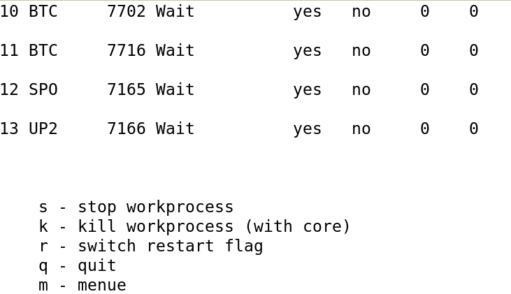
Specify the Process ID Serial Number 0-13 and Confirm “Y” to kill the Process.

- if the Processes Could not be killed using SM50 / DPMON then use Task Manager or “Kill -9 PID ” at Unix Level,.
- SM50 is also used to Display the Memory Consumed by Process
- Work Process Traces are displayed using the option
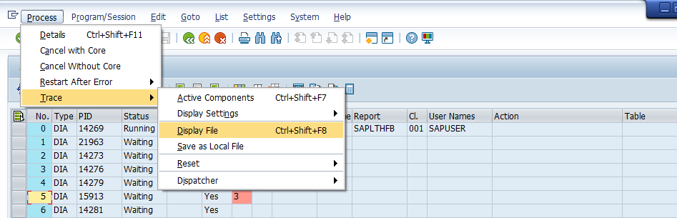
It is used to specify why the work process has been restarted and processes connectivity with the database.
Maximum Number of Work Processes:
Parameter “rdisp/wp_max_no” is used to set the limit for all the configurable work processes on the system.Ensure that there is sufficient memory for the processes else the system may be choked. From version Netweaver 7.3 this value is set to a maximum of 600.
Reserved (restricted) Work Processes
Generally the work process types are dialog, background,update and spool . A New Process Type Restricted(reserved) in Introduced in Netweaver 7.3. The number of initial work processes (as with the other types also) is specified in the profile parameter “rdisp/wp_no_restricted”. No further reserved WPs can be created while the system is running.
These are created on demand when there is a system blockade. Example during deadlocks an additional process is created to resolve the issue. Reserved Work Processes are only of type Dialog.
Dynamic Work Processes:
If the dynamic work processes are active (rdisp/dynamic_wp_check=TRUE), the system can start new work processes up to the limit specified in rdisp/wp_max_no in order to resolve deadlocks. Dynamic work processes can have different types (dialog, batch, update,spool) where as restircted are only of type dialog.
The possibility of creating processes dynamically is also used for handling deadlocks. After the bottleneck has been resolved, the “dynamic” process are stopped again
The maximum number of Processes on the Instance should not be more then 600 from netweaver7.3 onwards.
Preemptions:
This means that the processing of a request was interrupted because of a request with a higher priority. Processing is continued as soon as possible.
The Restrictions of Dialog Process:
- Maximum runt time is restricted
- The processes Execution time can be increased beyond 600 sec but it will be applicable to all the dialog users,subsequently system gets congested.
- Each dialog step executes only a part of the transaction and never completes the entire transaction in one step.
- Dialog could not handle or print the requests directly,btc requests directly and update requests synchronously in one step rather updates into temp tables.

