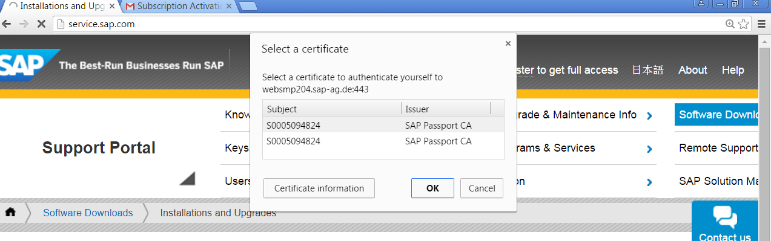
Select the User to Login to SAP Market Place
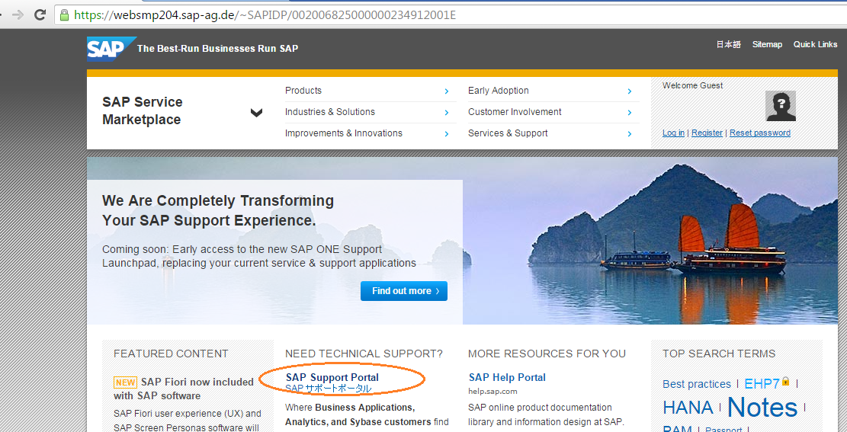
Click on SAP Support Portal
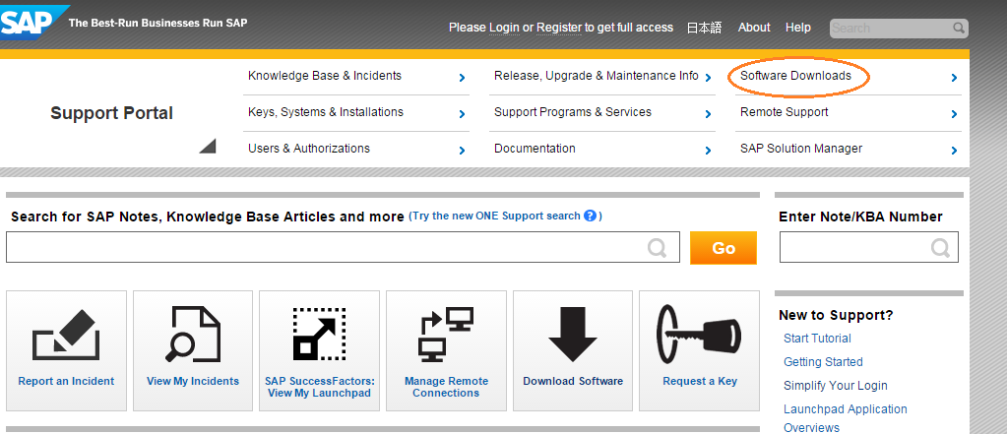
Click on Software Downloads
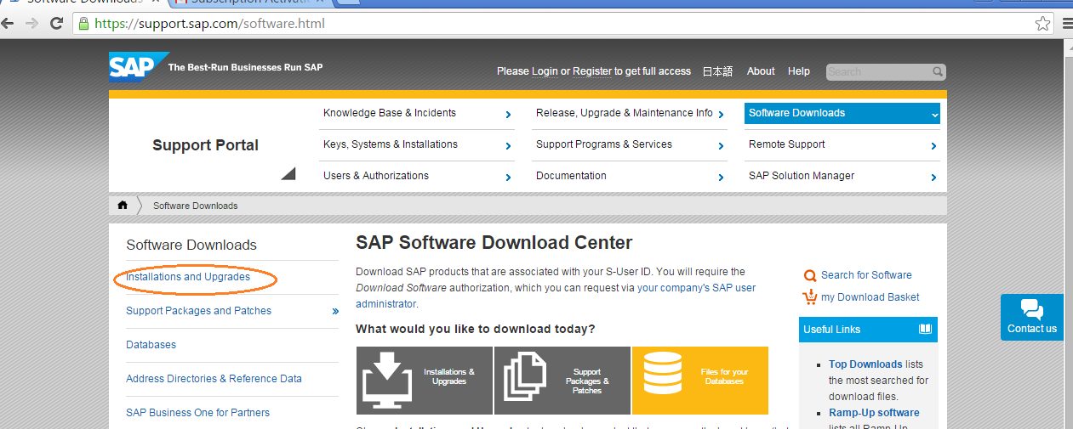
Click on Installations and Upgrades
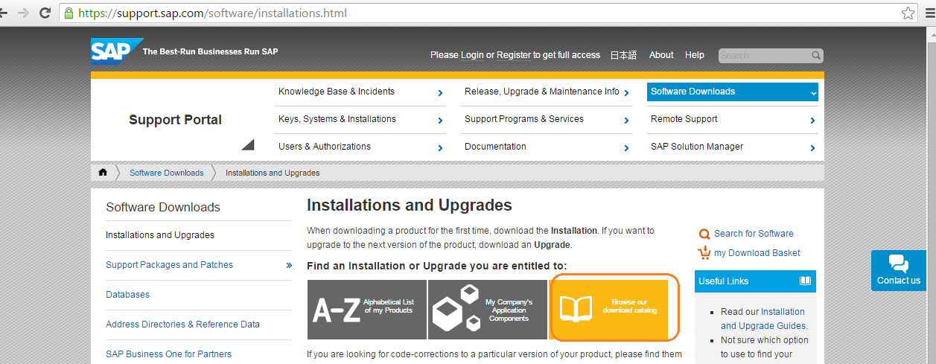
Click on Browse our Download Catalog
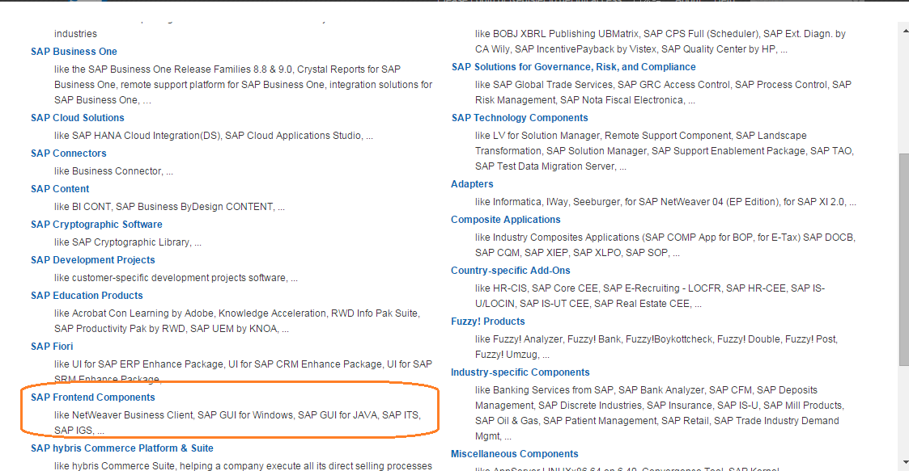
Select Frontend Components
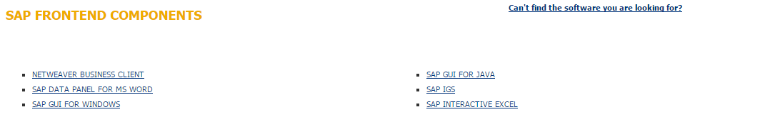
Select SAP GUI for Windows
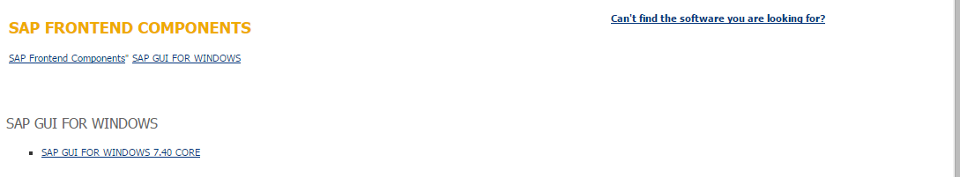
Select GUI for Windows 740 Core
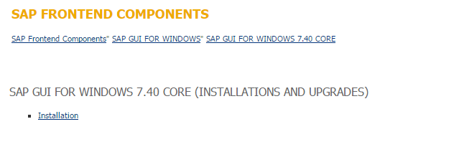
Select Installation
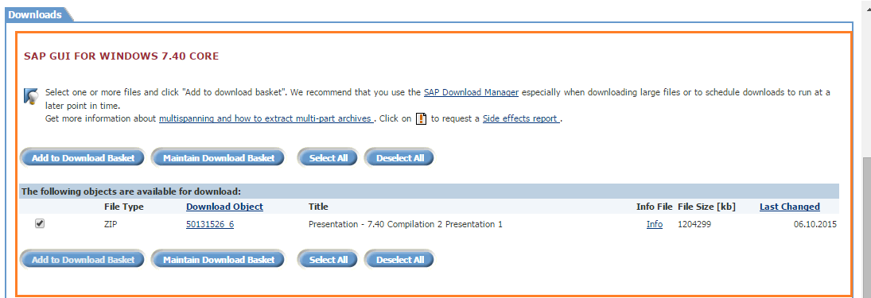
Select and add to the Download Basket.

Download the Patches for SAP GUI for Windows 740 version
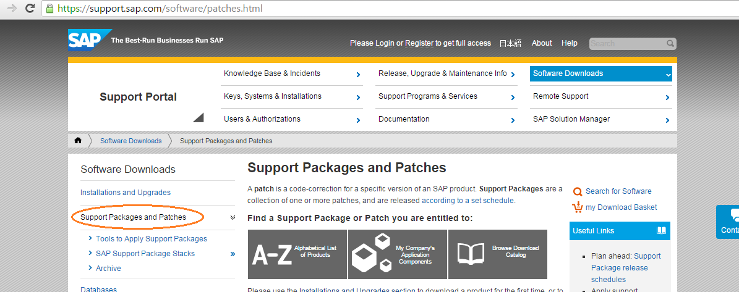
Select the support packages and patches→Browse our Download Catalog→Select SAP Frontend Components →Select SAP GUI FOR WINDOWS→ SAP GUI FOR WINDOWS 7.40 CORE→Win32
Select the Latest Version of Support Package or Follow the tradition of (N-1)
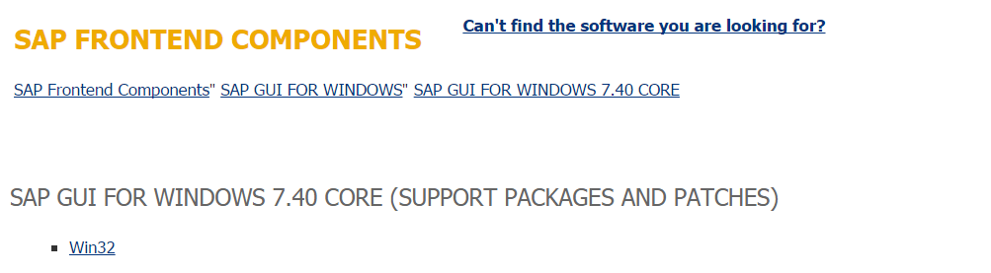
Select Win32 as the SAP GUI for Windows is released only for 32 bit Platforms.
Select and Add to the Download Basket.
Use SAP Download Manager to Download the SAP GUI

