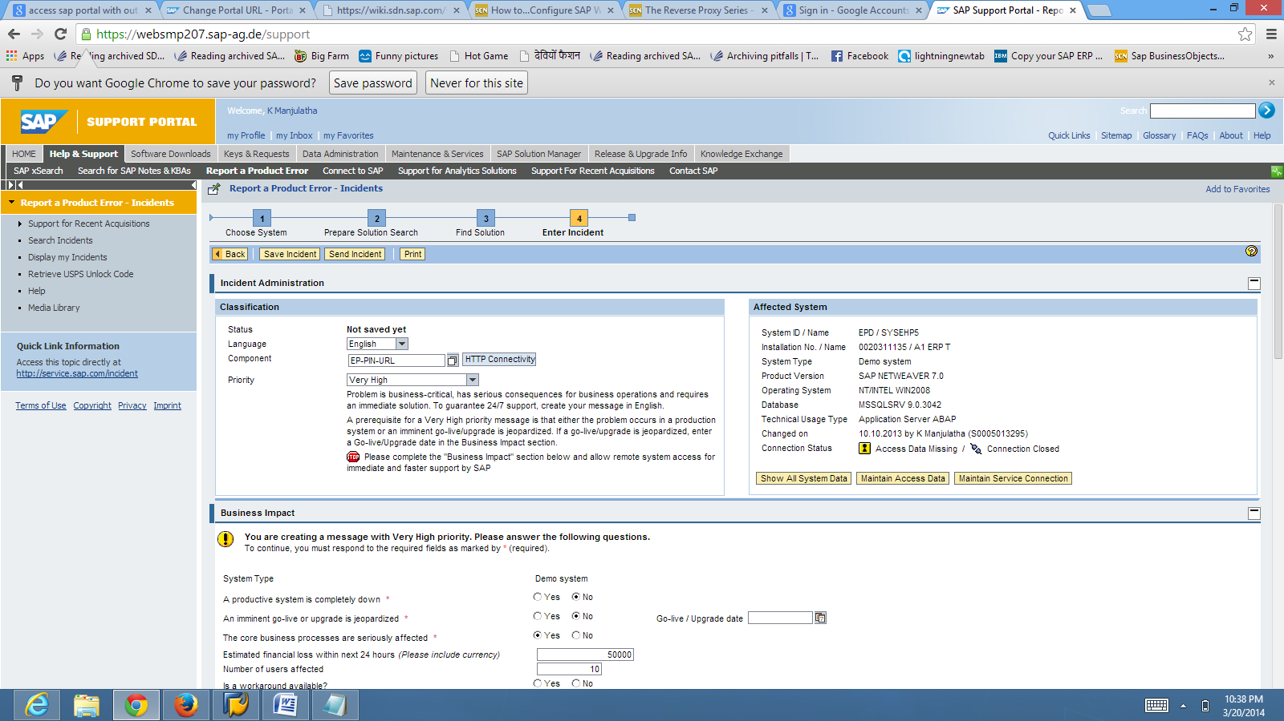

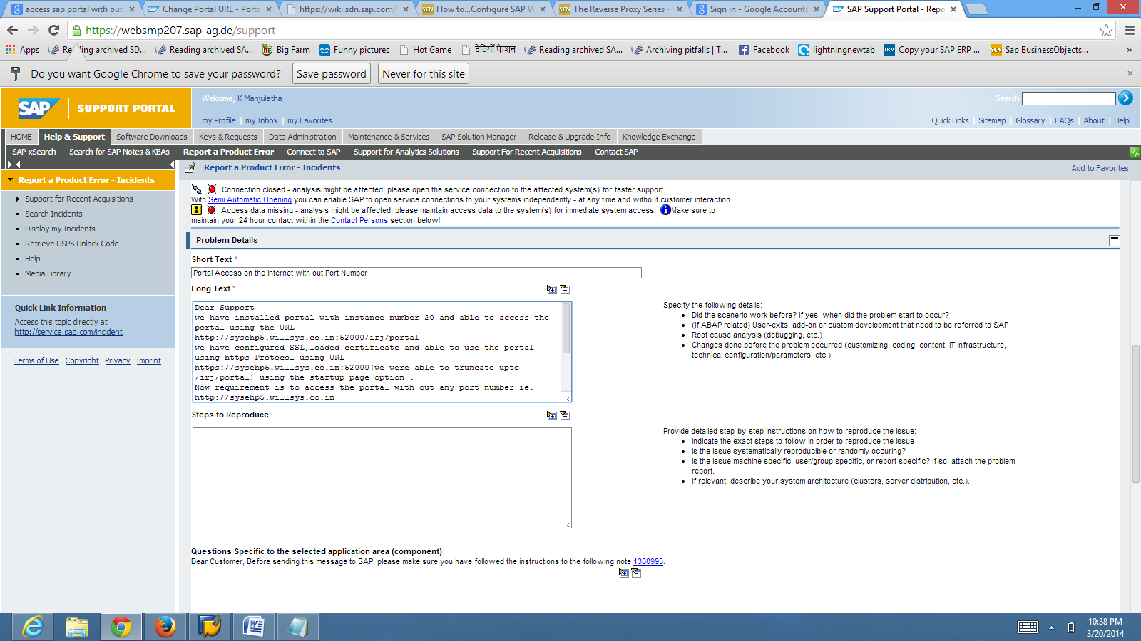

Dear Support

we have installed portal with instance number 20 and able to access the portal using the URL

http://sysehp5.willsys.co.in:52000/irj/portal

we have configured SSL,loaded certificate and able to use the portal using https Protocol using URL

https://sysehp5.willsys.co.in:52000(we were able to truncate upto /irj/portal) using the startup page option .

Now requirement is to access the portal with out any port number ie. http://sysehp5.willsys.co.in

I have installed the webdispatcher to terminate the SSL at port number.

I have tried setting out the dispatcher->http provider service-->ports-->parameter but efforts are going in vain

please advice how we can access our potal with out port number.

Thanks and Regards,

Ramu